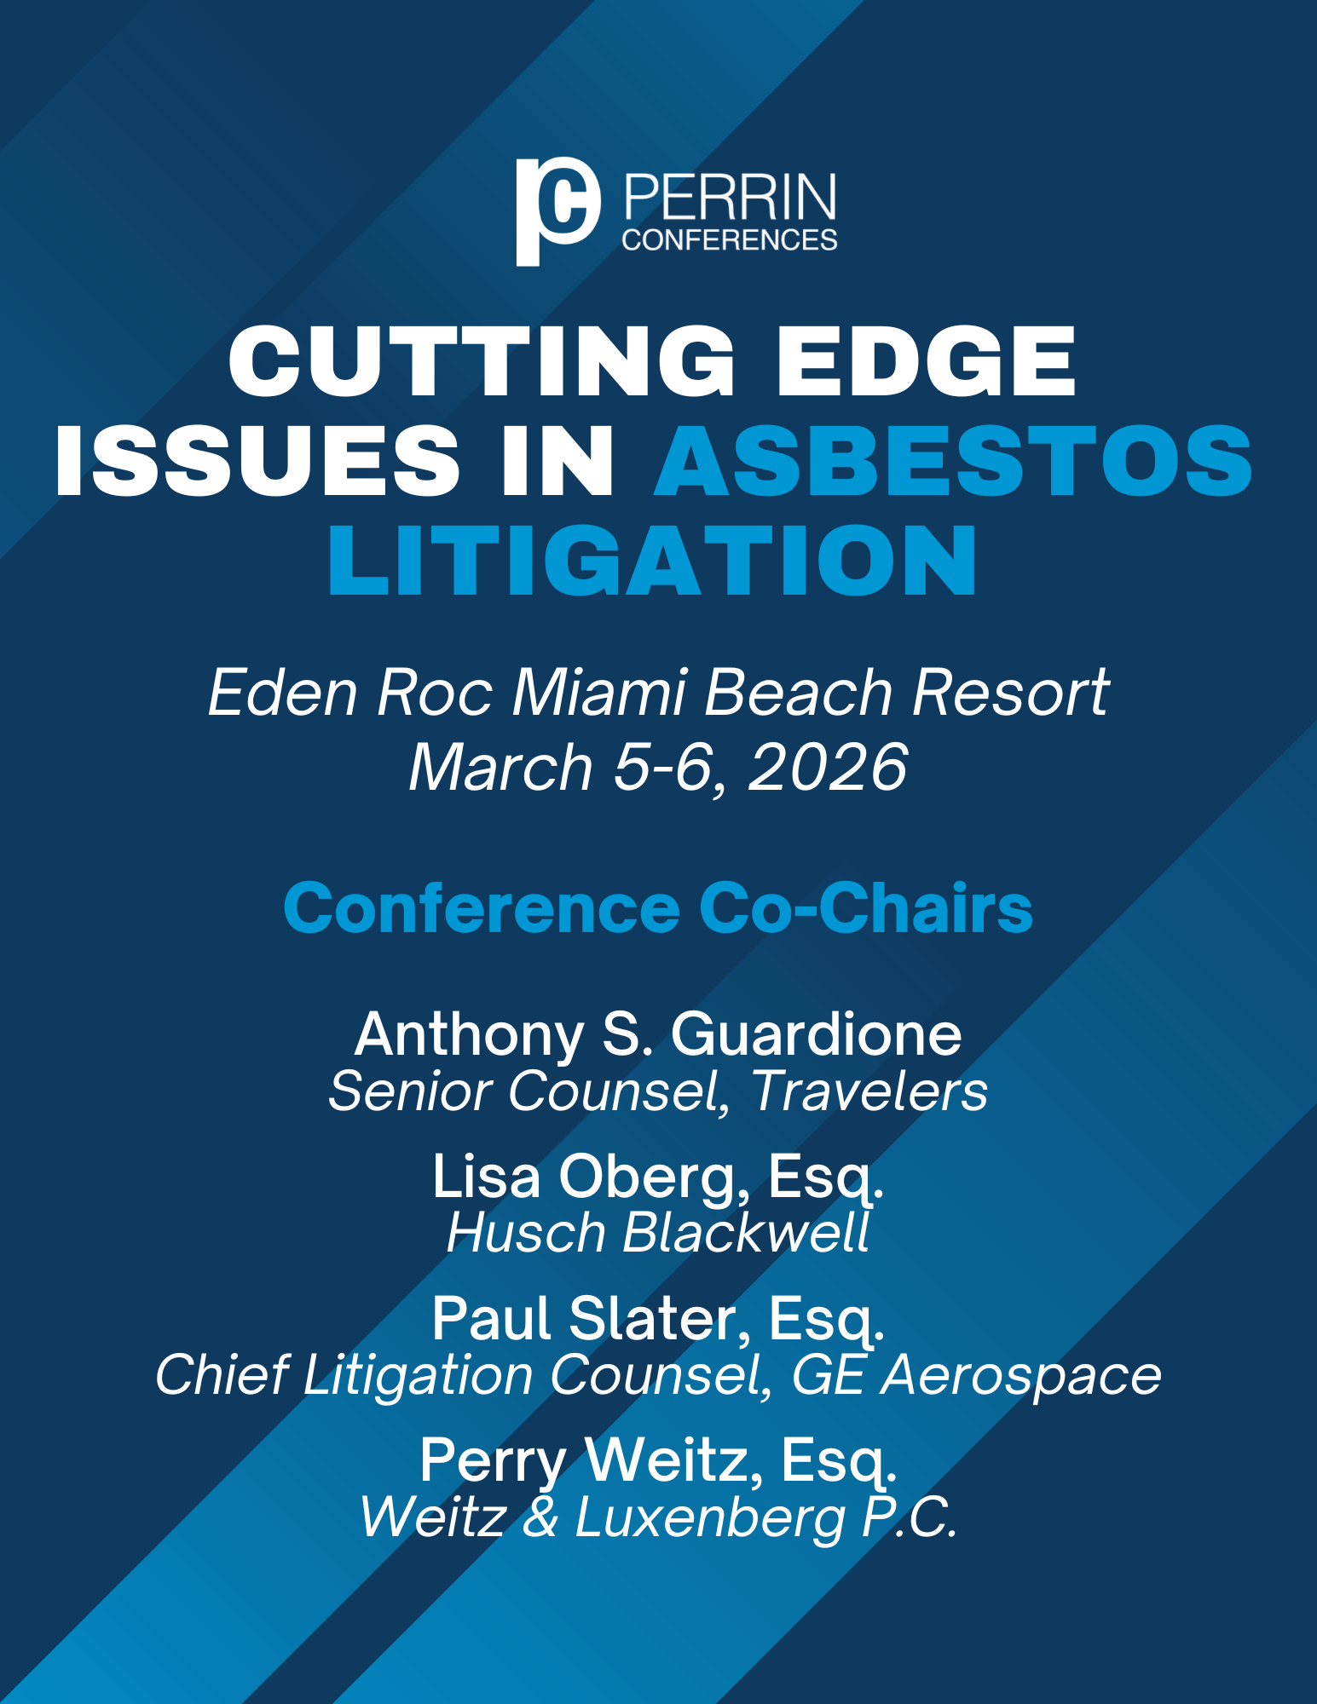

Perrin Conferences
Cutting-Edge Issues in Asbestos Litigation Conference
Eden Roc Miami Beach Hotel (Miami, FL)
March 5-6, 2026

Wednesday, March 4, 2026
4:00 PM – Registration

4:30 PM – 5:30 PM – Rapid Connections Session (Spa Garden)

Kick start the conference and join us for a fun express networking event providing face-to-face time with judges, in-house counsel, and insurance executives. This is your opportunity to have several short conversations where you can ask questions, exchange information, discuss professional backgrounds, and explore potential collaborations in a casual environment. The goal is to facilitate quick and efficient introductions, allowing participants to make valuable connections within a short period. We will gather at round tables and spend a set period of time meeting multiple people. When you hear the signal, it’s time to rotate and meet someone new! Cocktails will be provided.
Session hosts:
Hon. Andrew K. Carruthers, Circuit Court, Madison County, Edwardsville, IL
Hon. Reemberto Diaz, Osvaldo N. Soto Miami-Dade Justice Center, Miami, FL
Anthony S. Guardione, Senior Counsel, Travelers, Hartford, CT
Hon. Eric Schumacher, Coordinating Judge for New York City Asbestos Litigation (NYCAL), Supreme Court of the State of New York, New York, NY
Hon. Maura Slattery Boyle, Circuit Court of Cook County, Chicago, IL

5:30 PM – 6:30 PM – Networking Cocktail Reception (Spa Garden)

Thursday, March 5, 2026
8:00 AM – 8:45 AM – Light Breakfast and Registration

8:45 AM – 9:00 AM – Welcome and Co-Chair Opening Remarks (Eden Roc II)
Anthony S. Guardione, Senior Counsel, Travelers, Hartford, CT
Lisa L. Oberg, Esq., Husch Blackwell, Oakland, CA
Paul Slater, Esq., Chief Litigation Counsel, GE Aerospace, Fairfield, CT
Perry Weitz Esq., Weitz & Luxenberg P.C., New York, NY

9:00 AM – 10:00 AM – National Trends in Asbestos Litigation

- Filing trends: Disease, jurisdiction and plaintiff firms
- Hot and emerging jurisdictions
- The footprint and the future of the litigation: expectations and projections
- Assessing case risk

David Breslau, Senior Asbestos Claim Analyst – Asbestos Strategic Unit, Resolute Management, Inc., Philadelphia, PA
Kathrin Hashemi, Managing Director, KCIC, Washington, DC
Lee Ziffer, Esq., Gay Jones & Kuhn PLLC, New Orleans, LA

Additional Speakers to be Added.

10:00 AM – 10:45 AM – Talc Litigation
James M. Kramer, Esq., Simmons Hanly Conroy, New York, NY
Pierre Ratzki, Esq., Weitz & Luxenberg P.C., New York, NY
Amanda Webber, Senior Claims Technical Director, Allianz Reinsurance America, Inc., Petaluma, CA

10:45 AM – 11:00 AM – Break (Eden Roc II Foyer)

11:00 AM – 12:00 PM – From Claims Management to Enterprise Risk: Rethinking Asbestos Litigation in the Boardroom Era
- Examine asbestos litigation as a long-term, repeat-player environment, reframing it from individual claims to enterprise decision-making
- How financial predictability, reputation, and credibility among the same players who see each other year after year shape real-world outcomes
Kerryann M. Cook, Esq., The Cook Group, New York, NY
Michael Maienza, Esq., Vogelzang Law, Chicago, IL
Raymond D. Rushing, Corporate Counsel, Cummins Inc., Chicago, IL
Jessica McMullen Zimmerman, Esq., Corporate Counsel, International Motors, Chicago, IL

12:00 PM – 1:30 PM – Lunch (on your own)

1:30 PM – 2:15 PM – Recent Bankruptcies and the Impact on Asbestos Litigation

Lisa Nathanson Busch, Esq., Simmons Hanly Conroy, New York, NY
Kevin M. Davis, Esq., Caplin & Drysdale, Washington, DC
Adam S. Dreksler, Esq., Weitz & Luxenberg P.C., New York, NY
David J. Molton, Esq., Brown Rudnick LLP, New York, NY

2:15 PM – 3:15 PM – Ongoing Trends in Asbestos Litigation
- Federal Officer Removal and Impact of Disclaimer
- Receivership
- Legacy Settlements
- Recent large verdicts

Joseph W. Belluck, Esq., Belluck Law, LLP, New York, NY
John Elder, Esq., Paine Bickers Elder King & Williams, Knoxville, TN
Paul Slater, Esq., Chief Litigation Counsel, GE Aerospace, Fairfield, CT

3:15 PM – 3:30 PM – Break (Eden Roc II Foyer)

3:30 PM – 4:30 PM – Damages: Proving Them and Collecting Them
- Remittitur
- Insurance discovery
- Management of damages and various approaches

Bethann S. Kagan, Esq., Shein Law, Philadelphia, PA
Brittany Russell, Esq., Weitz & Luxenberg P.C., New York, NY

Additional Speakers to be Added.

4:30 PM – 5:30 PM – Judicial Perspectives

Moderator: Perry Weitz Esq., Weitz & Luxenberg P.C., New York, NY
Hon. Andrew K. Carruthers, Circuit Court, Madison County, Edwardsville, IL
Hon. Eric Schumacher, Coordinating Judge for New York City Asbestos Litigation (NYCAL), Supreme Court of the State of New York, New York, NY
Hon. Maura Slattery Boyle, Circuit Court of Cook County, Chicago, IL

5:30 PM – 6:30 PM – Networking Cocktail Reception (Spa Garden)
Sponsored by: Swanson, Martin & Bell, LLP
Friday, March 6, 2026
8:30 AM – 9:15 AM – Light Breakfast (Eden Roc II Foyer)

9:15 AM – 10:15 AM – Insurance and In-House Counsel Perspectives
- How do you evaluate the risk?

David Breslau, Senior Asbestos Claim Analyst – Asbestos Strategic Unit, Resolute Management, Inc., Philadelphia, PA
Kate Cook, Assistant General Counsel, Jacobs, Boston, MA
Brittany I. Hayes, Claims Manager, Allianz Reinsurance America, Inc., Boston, MA
Michael Owen, Claims Counsel, The RiverStone Group, Manchester, NH

10:15 AM – 11:00 AM – Genetics Overview

- The science is changing
- Genetic evidence in low dose asbestos cases

Hon. Jo-Lynne Lee (Ret.), Mediator/Arbitrator, ADR Services, Inc., San Francisco, CA
Kelvin Wyles, Esq., Husch Blackwell, Los Angeles, CA

Additional Speakers to be Added.

11:00 AM – 12:00 PM – AI and Ethical Considerations
- Court orders requiring AI certifications (across the country)
- Sanctions
- How to avoid the pitfalls
- Communicating with clients about the use of AI

James Campbell, Esq., The Lanier Law Firm, Chicago, IL
Melanie Chung-Tims, Esq., MG+M The Law Firm, Miami, FL

Perrin Conferences
Cutting-Edge Issues in Asbestos Litigation Conference
Eden Roc Miami Beach Hotel (Miami, FL)
March 5-6, 2026

*Speaker and Agenda are subject to change.

CONFERENCE LOCATION

Eden Roc Miami Beach Hotel
4525 Collins Ave
Miami Beach, FL 33140

REGISTRATION

Registration Rate: $1,225
Paralegal Rate: $395

All in-house counsel and insurance claims professionals receive complimentary registration at Perrin Conferences live programs.

Contact Bethany Corio (bcorio@perrinconferences.com) 610-220-1817 or Lynnsey Perrin (lperrin@perrinconferences.com) 610-804-6165 with questions or to register at the complimentary rate.

Register Online: Cutting-Edge Issues in Asbestos Litigation Conference | Perrin Conferences

Register by Mail/E-mail: Complete the Mail-In Registration Form at the end of brochure.

Mail to: Perrin Conferences, 214 Orchard Way, Wayne, PA 19087
Each registration includes private website access to course materials and admission to all sessions and networking events such as refreshment breaks and cocktail receptions.

Group discounts available, please inquire.

HOTEL ROOM BLOCKS

We suggest making your reservations as soon as possible, the discounted room block rates will sell out.

Eden Roc Miami Beach Hotel
4525 Collins Ave, Miami Beach, FL 33140
The group rate is $409/night, plus taxes and fees.

Click here to book online, email Reservations@nobuedenroc.com, or call 305-531-0000 and mention Perrin Conferences to make a reservation.

Cadillac Hotel & Beach Club, Autograph Collection (Marriott)
3925 Collins Ave, Miami Beach, FL 33140

The group rate is $349/night, plus taxes and fees.

Email Allison Gill, agill@perrinconferences.com, to inquire about the group rate.

CLE & CE CREDIT INFORMATION

Applications are being made to all CLE states as requested by attendees. Perrin cannot guarantee accreditation in every state. Approval is determined by each jurisdiction’s governing body. This conference is approved for CE Adjuster credit in Florida and pending approval in New Hampshire, Oklahoma, and Texas.

Please note, there will be no partial credit awarded for CE credit – The full conference must be attended to earn CE credit. Please send CLE requests for state specific accreditation to Kelsey Minerd (kaminerd@perrinconferences.com).

CANCELLATION POLICY

If you cannot attend the conference, please notify us prior to February 18, 2026 and we will refund your fee, less a $25 administrative fee, or provide a credit for a future conference. The credit needs to be used within one year from the conference date.

Cancellations received on February 19, 2026 and after will not be refunded. You may enroll a substitute at any time before the conference starts. Cancellations received on February 19, 2026 and after may receive a credit for $200 less than the registration amount paid and can be used by their firm/company within one year from the conference date.

FINANCIAL AID POLICY

Perrin Conferences is dedicated to providing high-quality continuing legal education to attorneys interested in course offerings. Program registrants who are unable to afford registration fees due to financial hardship may apply for a complete registration waiver or reduction in fee. Factors to be considered include employment status and annual income. Please send a written letter to Lynnsey Perrin addressing your financial situation for consideration. All requests must be submitted 14 days prior to the start of the program and are kept confidential.

THANK YOU TO OUR SPONSORS AND PARTNERS

DIAMOND SPONSOR
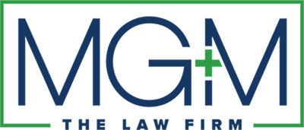

PLATINUM SPONSORS


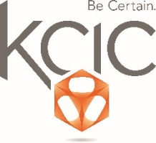
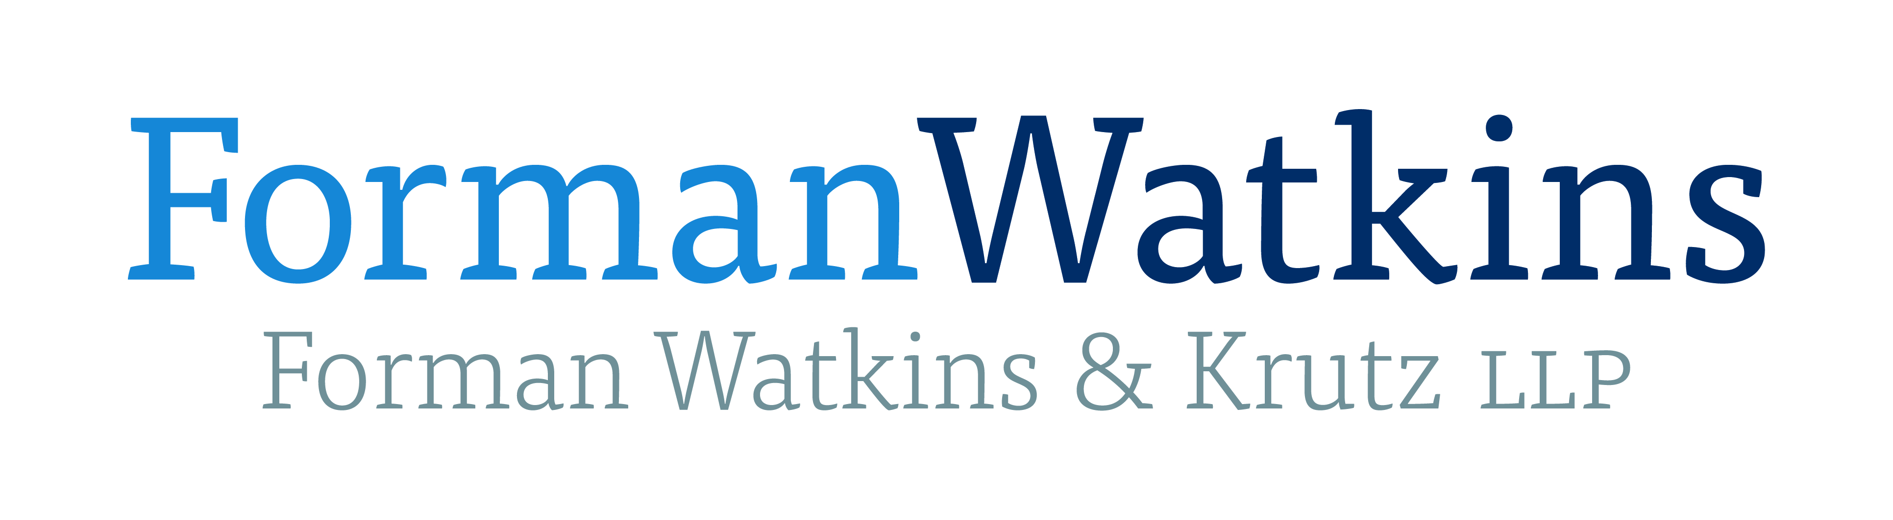


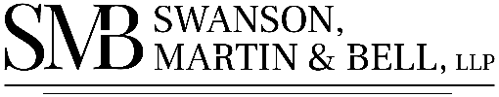
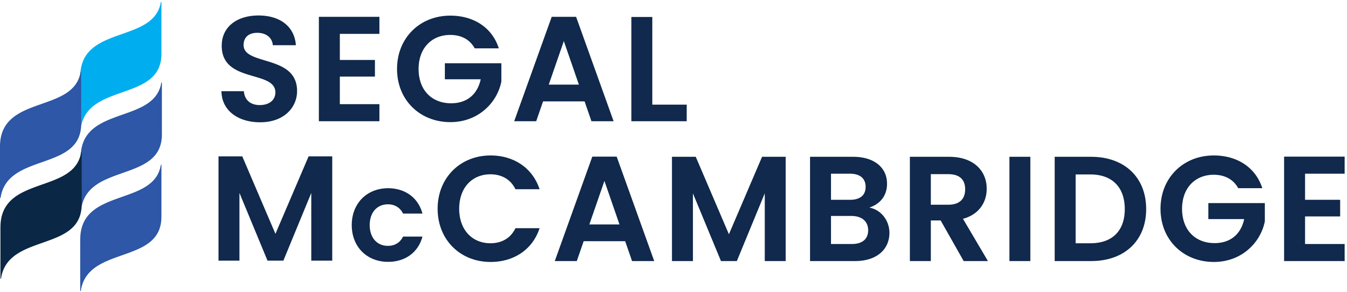

GOLD SPONSORS

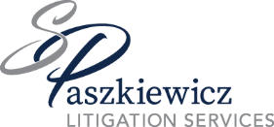
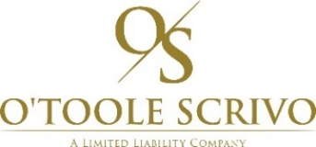





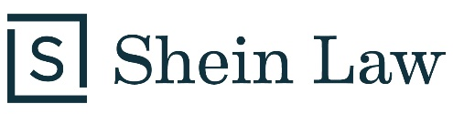




BLUE SPONSOR
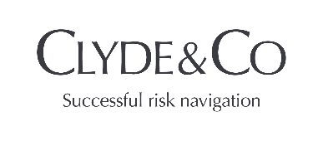

PERRIN PARTNERS



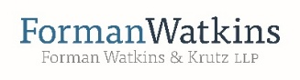
















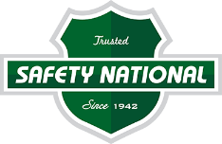







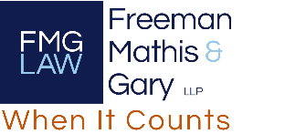
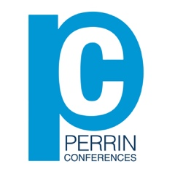
Perrin Conferences
Cutting-Edge Issues in Asbestos Litigation
March 5-6, 2026, Miami Beach
Mail-in Registration Form

Attendee Name ____________________________________________________________________
Company/Firm Name _______________________________________________________________
Address ___________________________________________________________________________
____________________________________________________________________________
City _______________________________________________________________________________
State ____________________________ Zip Code ________________________________________
Email Address ______________________________________________________________________
CIRCLE ONE: Attorney Non-Attorney Insurance Professional In-House Counsel
Registration Fee: $1,225
Paralegal Fee: $395
*All Insurance Professionals & In-House Counsel receive Complimentary attendance
Name on Card ______________________________________________________________________
Credit Card Number ________________________________________________________________
Expiration Date _____________________ Code _________________ Zip ______________
Please Mail Form to: Perrin Conferences, 214 Orchard Way, Wayne, PA 19087
Email Form to: bcorio@perrinconferences.com or lperrin@perrinconferences.com
Make Checks Payable to: Perrin Conferences, LLC

