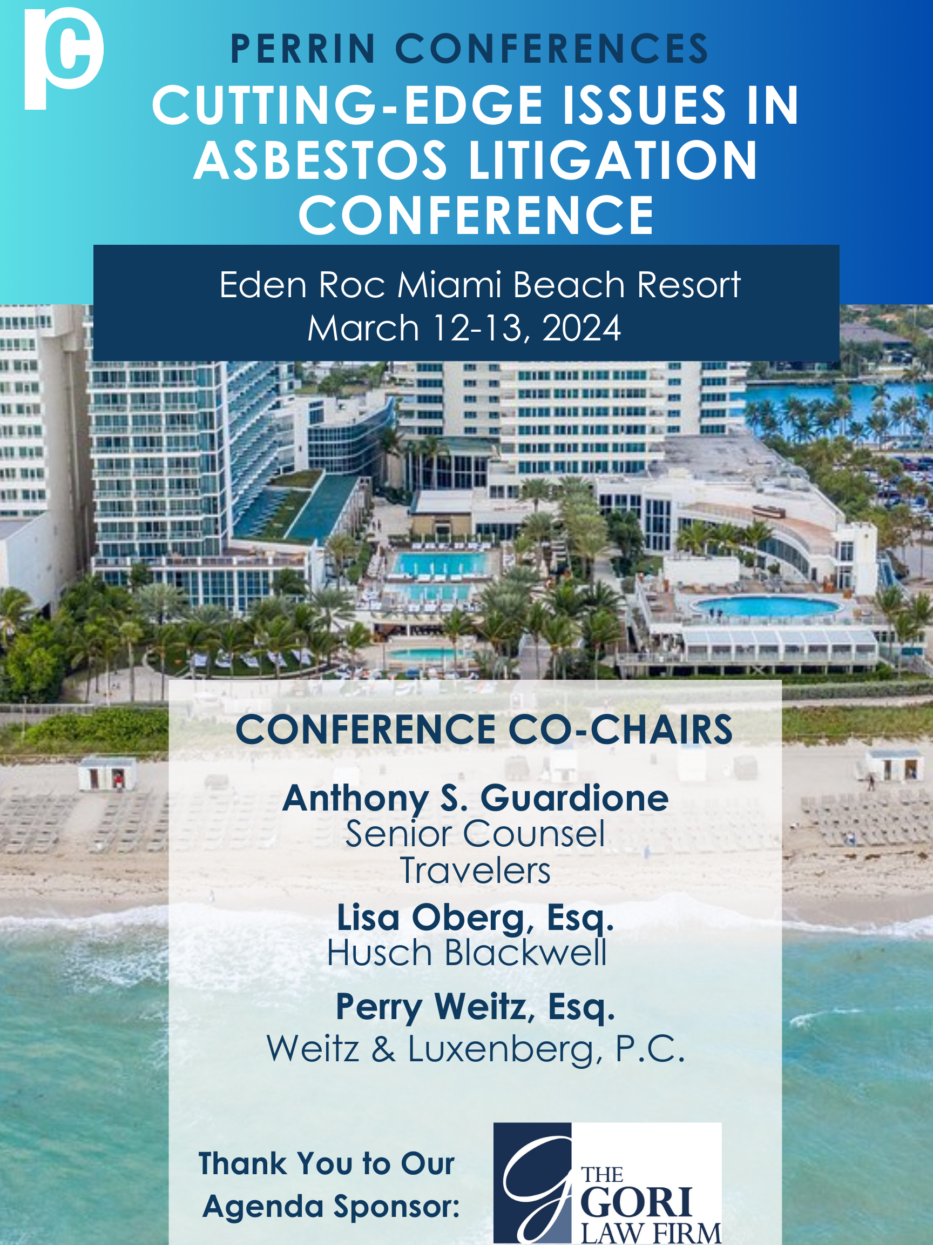
Perrin Conferences
Cutting-Edge Issues in Asbestos Litigation Conference
Eden Roc Hotel (Miami, FL)
March 12-13, 2024

Monday, March 11, 2024

4:00 PM – Registration (Eden Roc II Foyer)

4:30 PM – 5:30 PM – Rapid Connections Session (Eden Roc II)

Kick start the conference and join us for a fun express networking event providing face-to-face time with judges, in-house counsel, and insurance executives. This is your opportunity to have several short conversations where you can ask questions, exchange information, discuss professional backgrounds, and explore potential collaborations in a casual environment. The goal is to facilitate quick and efficient introductions, allowing participants to make valuable connections within a short period. We will gather at round tables and spend a set period of time meeting multiple people. When you hear the signal, it’s time to rotate and meet someone new! Cocktails will be provided.
Session hosts:
Anthony S. Guardione, Senior Counsel, Travelers, Hartford, CT
Frederick C. Schaefer, Associate Vice President, Nationwide, Wausau, WI
Hon. Laura A. Seigle, Los Angeles County Superior Court, Los Angeles, CA
Hon. Patrick J. Sherlock, Circuit Court of Cook County, Chicago, IL
Hon. Adam Silvera, Supreme Court of the State of New York, New York, NY
Hon. Stephen Stobbs, Circuit Court, Madison County, IL
Craig Ziolkowski, Assistant Vice President, Resolute Management, Inc., Chicago, IL

5:30 PM – 7:00 PM – Opening Cocktail Reception (Outdoor Spa Terrace)
Sponsored by: Husch Blackwell and Simmons Hanly Conroy

Tuesday, March 12, 2024

8:00 AM – 8:45 AM – Registration and Light Breakfast (Eden Roc II Foyer)
Sponsored by: KCIC

8:45 AM – 9:00 AM – Welcome and Co-Chair Opening Remarks (Eden Roc II)

Anthony S. Guardione, Senior Counsel, Travelers, Hartford, CT
Lisa L. Oberg, Esq., Husch Blackwell, Oakland, CA
Perry Weitz Esq., Weitz & Luxenberg P.C., New York, NY

9:00 AM – 10:00 AM – The Top Emerging Trends in Asbestos Litigation

- Filing trends: Disease, jurisdiction and plaintiff firms
- Hot and emerging jurisdictions
- Defense-Plaintiff Coordination

Moderator: Joseph W. Belluck, Esq., Belluck & Fox, LLP, New York, NY
Debra Forsythe, Sr. Director, Epiq, Charlotte, NC
Kathrin Hashemi, Director, KCIC, Washington, DC
Kevin E. Hexstall, Esq., Marshall Dennehey, Philadelphia, PA
Frederick C. Schaefer, Associate Vice President, Nationwide, Wausau, WI

10:00 AM – 11:00 AM – Recent Bankruptcies and the Impact on Asbestos Litigation

- Update on bankruptcies
- Is the Texas 2-step dead? What are alternatives?
- Picking a jurisdiction

Moderator: Perry Weitz Esq., Weitz & Luxenberg P.C., New York, NY
John Baden, Esq., Motley Rice, Mount Pleasant, SC
Lisa Nathanson Busch, Esq., Simmons Hanly Conroy, New York, NY
David J. Molton, Esq., Brown Rudnick LLP, New York, NY

11:00 AM – 11:15 AM – Break (Eden Roc II Foyer)

11:15 AM – 12:00 PM – Significant Developments in Asbestos Employer Liability Cases
- Altman case

Moderator: Hon. Patrick J. Sherlock, Circuit Court of Cook County, Chicago, IL
Michael C. Cooney, Esq., Cooney & Conway, Chicago, IL
Michael Maizena, Esq., Vogelzang Law, Chicago, IL
James P. O’Shea, II, Esq., Husch Blackwell, Chicago, IL

12:00 PM – 1:15 PM – Women’s Networking Lunch (Key Biscayne Room)
Sponsored by: Foley & Mansfield and Gordon Rees Scully Mansukhani, LLP

Kate Cook, Assistant General Counsel, Jacobs, Boston, MA
Antoinette D. Hubbard, Esq., Maron Marvel, Wilmington, DE
Sarah Paszkiewicz, CEO and Founder, Paszkiewicz Litigation Services, Glen Carbon, IL
Carol M. Tempesta, Esq., Foley Mansfield, New York, NY
Erin M. Voyik, Esq, VP/Director, APO Strategy & Claims Counsel, The RiverStone Group, Manchester, NH

12:00 PM – 1:15 PM – Lunch (on your own)

1:15 PM – 2:15 PM – Recent Large Verdicts
- What to expect going forward?
- How are jurors changing and what do we expect going forward
- Managing jury picks
- Jurisdictional impact
- How do you evaluate the risk?

Lindsey Cheek, Esq., The Cheek Law Firm, New Orleans, LA
Lily Keefer, Director, STOUT, Chicago, IL
Pierre Ratzki, Esq., Weitz & Luxenberg, New York, NY
Stuart Simon, President, American Jury Centers, Boca Raton, FL
Erin Smith-Corbally, Manager, Asbestos Claims, The RiverStone Group, Manchester, NH
Daniel Wasserberg, Esq., Meirowitz & Wasserberg, New York, NY

2:15 PM – 2:45 PM – The Lung Cancer Docket Update

Clayton E. Dickey, Esq., Rasmussen Dickey Moore, Kansas City, MO
Mark Thomas, Esq., The Gori Law Firm, Edwardsville, IL

2:45 PM – 3:00 PM – Break (Eden Roc II Foyer)

3:00 PM – 3:30 PM – The Rapidly Developing Science and Medicine on Genetic Cancer Treatments

Timothy L. Krippner, Esq., MG+M The Law Firm, Chicago, IL
Jennifer Alesio, Esq., Simmons Hanly Conroy, San Francisco, CA

3:30 PM – 4:30 PM – The Judicial Perspectives

Moderator: Joseph Cagnoli, Jr., Esq., Goldberg Segalla, Philadelphia, PA
Moderator: Perry Weitz Esq., Weitz & Luxenberg P.C., New York, NY
Hon. Laura A. Seigle, Los Angeles County Superior Court, Los Angeles, CA
Hon. Adam Silvera, Supreme Court of the State of New York, New York, NY
Hon. Stephen Stobbs, Circuit Court, Madison County, IL

4:30 PM – 6:00 PM – Networking Cocktail Reception (Outdoor Spa Garden)
Sponsored by: LitPro, MG+M The Law Firm and Polsinelli

Wednesday, March 13, 2024

8:15 AM – 9:00 AM – Light Breakfast (Eden Roc II Foyer)

9:00 AM – 10:00 AM – Talc Litigation Update

- Overview of proving asbestos content
- Establishing significant causation
- Litigating talc mesos

Amanda R. Cachaldora, Esq., MG+M The Law Firm, Miami, FL
John D. Cosmich, Esq., Cosmich Simmons & Brown PLLC, Jackson, MS
Olivia Kelly, Esq., Simmons Hanly Conroy, New York, NY

10:00 AM – 11:00 AM – The In-House Counsel and Insurance Perspectives

Moderator: Beverly M. Bond, Esq., Gordon Rees Scully Mansukhani, LLP, Dallas, TX
Christopher W. Bowman, Managing Counsel of the Product Litigation & Insurance Group, The Dow Chemical Company, Midland, MI
Paul Slater, Esq., Senior Counsel, General Electric Company, Fairfield, CT
Craig Ziolkowski, Assistant Vice President, Resolute Management, Inc., Chicago, IL

11:00 AM – 12:00 PM – Personal Jurisdiction and Legislative Updates

- Analyzing the effects of the Mallory Decision

John P. Arranz, Esq., Swanson, Martin & Bell LLP, Chicago, IL
Michael A. Brockland, Esq., SWMW Law, St. Louis, MO
Perry J. Browder, Esq., Simmons Hanly Conroy, Alton, IL
David E. Freed, Esq., Hawkins Parnell & Young LLP, New York, NY

Perrin Conferences
Cutting-Edge Issues in Asbestos Litigation Conference
March 12-13, 2024
Eden Roc Miami Beach Hotel

*Speaker and Agenda are subject to change.

CONFERENCE LOCATION
Eden Roc Miami Beach Hotel
4525 Collins Ave
Miami Beach, FL 33140

REGISTRATION
Registration Rate: $1225
Paralegal Rate: $395
All in-house counsel and insurance claims professionals receive complimentary registration at Perrin Conferences live programs.
Contact Bethany Corio (bcorio@perrinconferences.com) 610-220-1817 or Lynnsey Perrin (lperrin@perrinconferences.com) 610-804-6165 with questions or to register at the complimentary rate.
Register Online: Cutting-Edge Issues in Asbestos Litigation Conference | Perrin Conferences
Register by Mail/E-mail: Complete the Mail-In Registration Form at the end of brochure.
Mail to: Perrin Conferences, 214 Orchard Way, Wayne, PA 19087
Each registration includes private website access to course materials and admission to all sessions and networking events such as refreshment breaks and cocktail receptions.
Group discounts available, please inquire.
HOTEL ROOM BLOCK
Eden Roc Miami Beach Hotel
4525 Collins Ave, Miami Beach, FL 33140
Please make your room reservations through the group booking link. The group rate is $399/night. We suggest making your reservations as soon as possible, the discounted room block rates are ending soon.
Reservation Link Perrin Conferences Room Block

Cadillac Hotel & Beach Club, Autograph Collection
3925 Collins Ave, Miami Beach, FL 33140
We have opened an additional room block at the Cadillac Hotel & Beach Club. Please make your room reservations through the group booking link below. The group rate is $459/night. We suggest making your reservations as soon as possible before the room block sells out.
Book your group rate for Perrin Asbestos

CLE & CE CREDIT INFORMATION
Applications are being made to all CLE states as requested by attendees. Perrin cannot guarantee accreditation in every state. Approval is determined by each jurisdiction’s governing body.
This conference is approved in Texas and Florida and pending approval in Oklahoma and New Hampshire for CE Adjuster credit.
Please note, there will be no partial credit awarded for CE credit – The full conference must be attended to earn CE credit. Please send CLE requests for state specific accreditation to Kelsey Minerd (kaminerd@perrinconferences.com).

CANCELLATION POLICY
If you cannot attend the conference, please notify us prior to February 27, 2024 and we will refund your fee or provide a credit for a future conference. The credit needs to be used within one year from the conference date.
Cancellations received on February 28, 2024 and after will not be refunded. You may enroll a substitute at any time before the conference starts. Cancellations received on February 28, 2024 and after may receive a credit for $200 less than the registration amount paid and can be used by their firm/company within one year from the conference date.

FINANCIAL AID POLICY
Perrin Conferences is dedicated to providing high-quality continuing legal education to attorneys interested in course offerings. Program registrants who are unable to afford registration fees due to financial hardship may apply for a complete registration waiver or reduction in fee. Factors to be considered include employment status and annual income. Please send a written letter to Lynnsey Perrin addressing your financial situation for consideration. All requests must be submitted 14 days prior to the start of the program and are kept confidential.
THANK YOU TO OUR SPONSORS AND PARTNERS
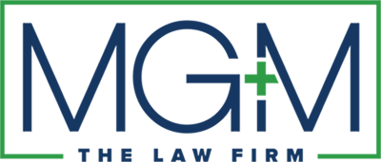
DIAMOND SPONSOR

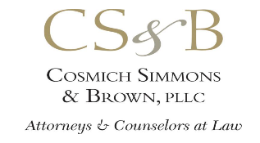
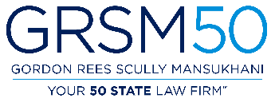
PLATINUM SPONSORS
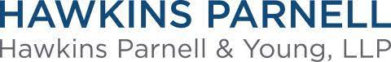
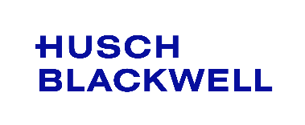

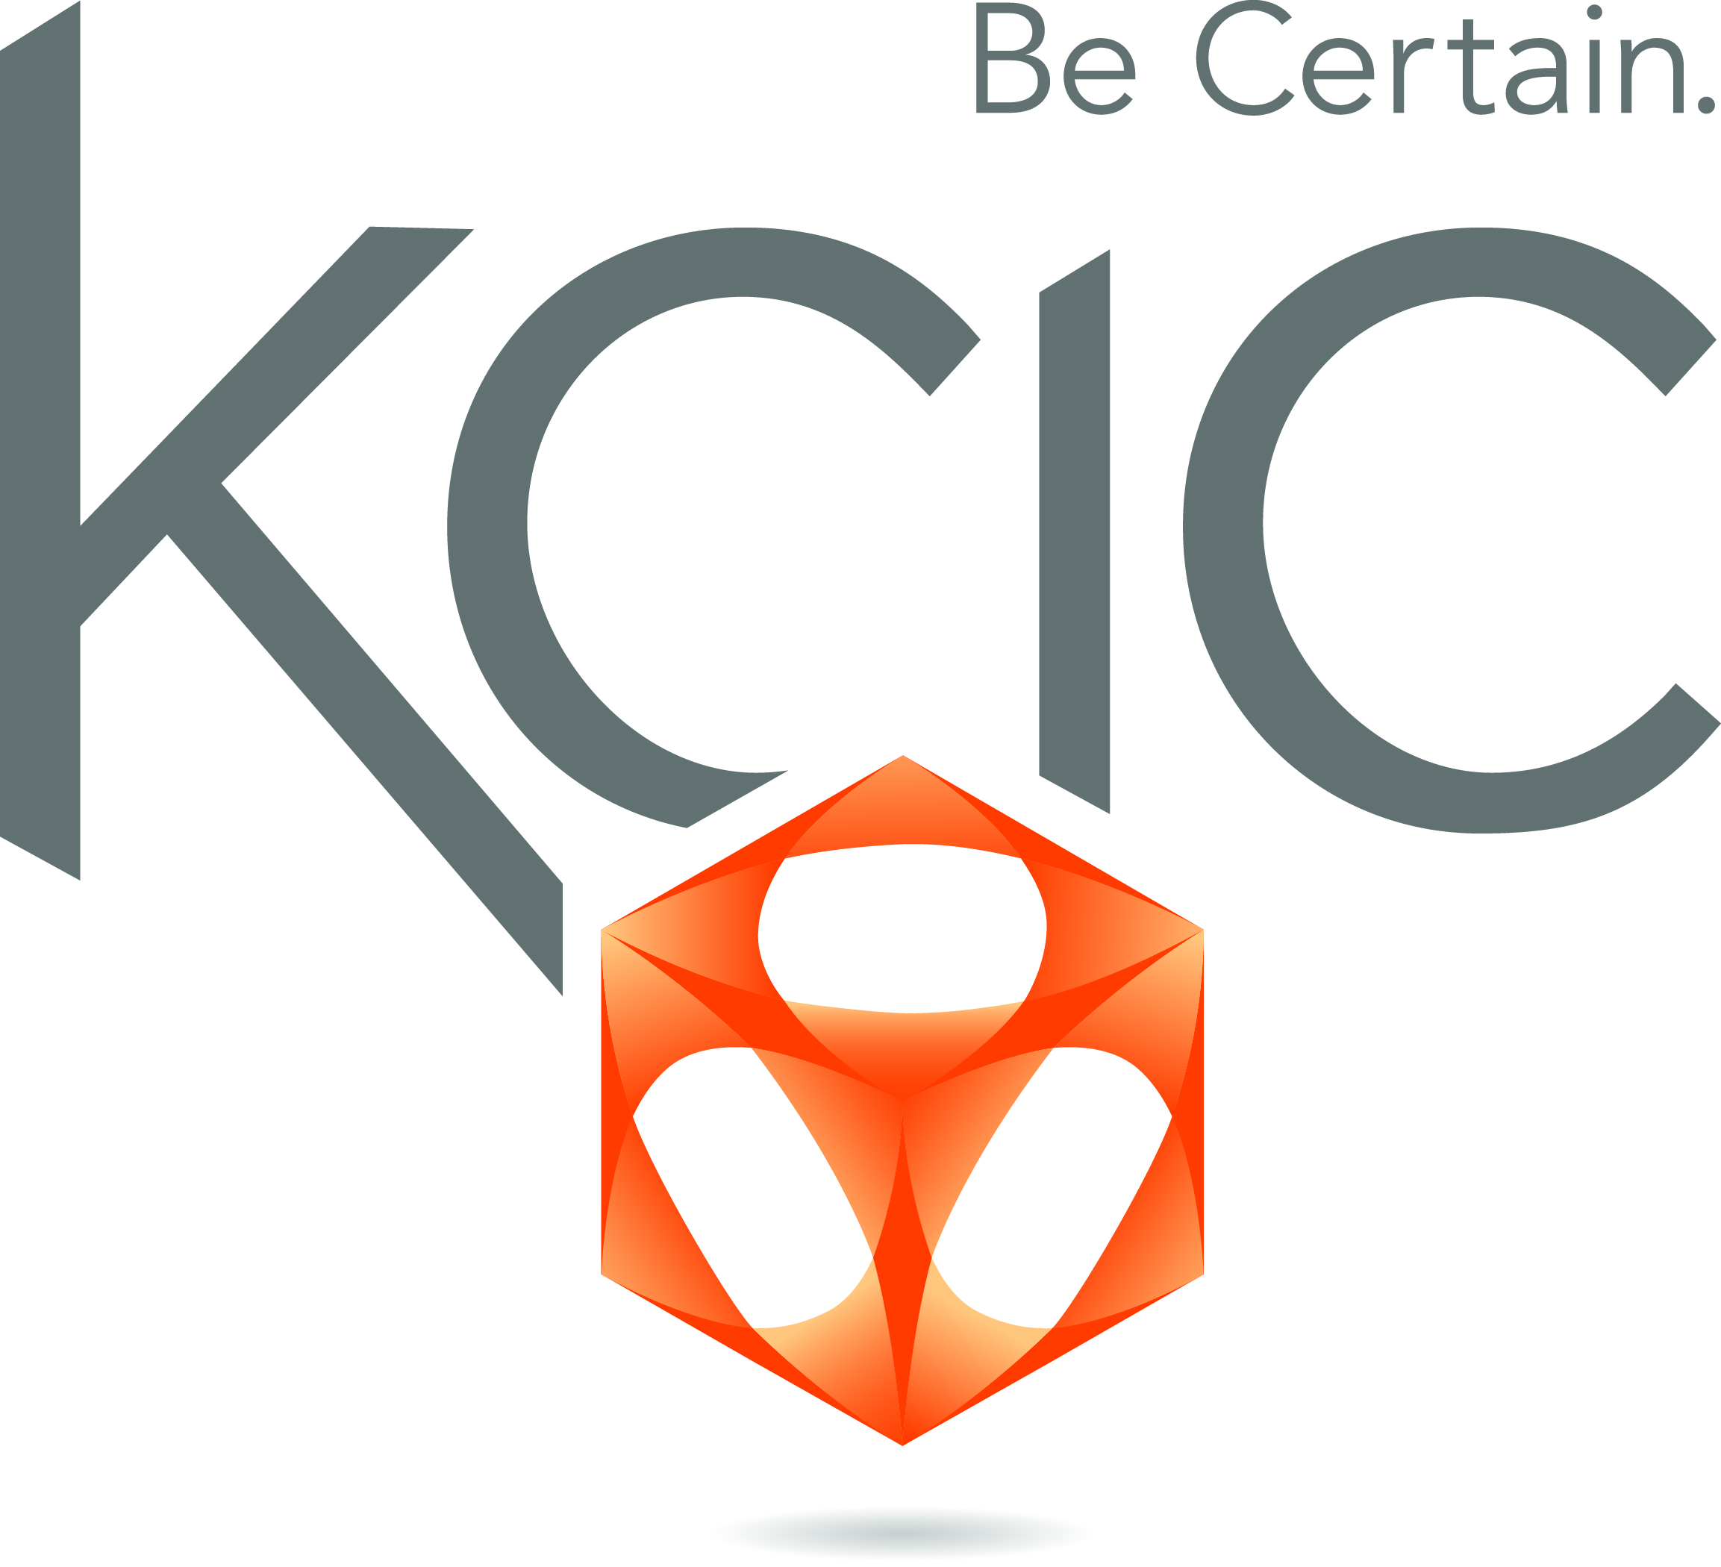



GOLD SPONSORS
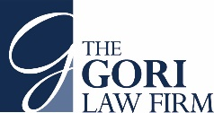

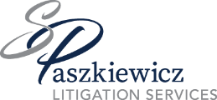
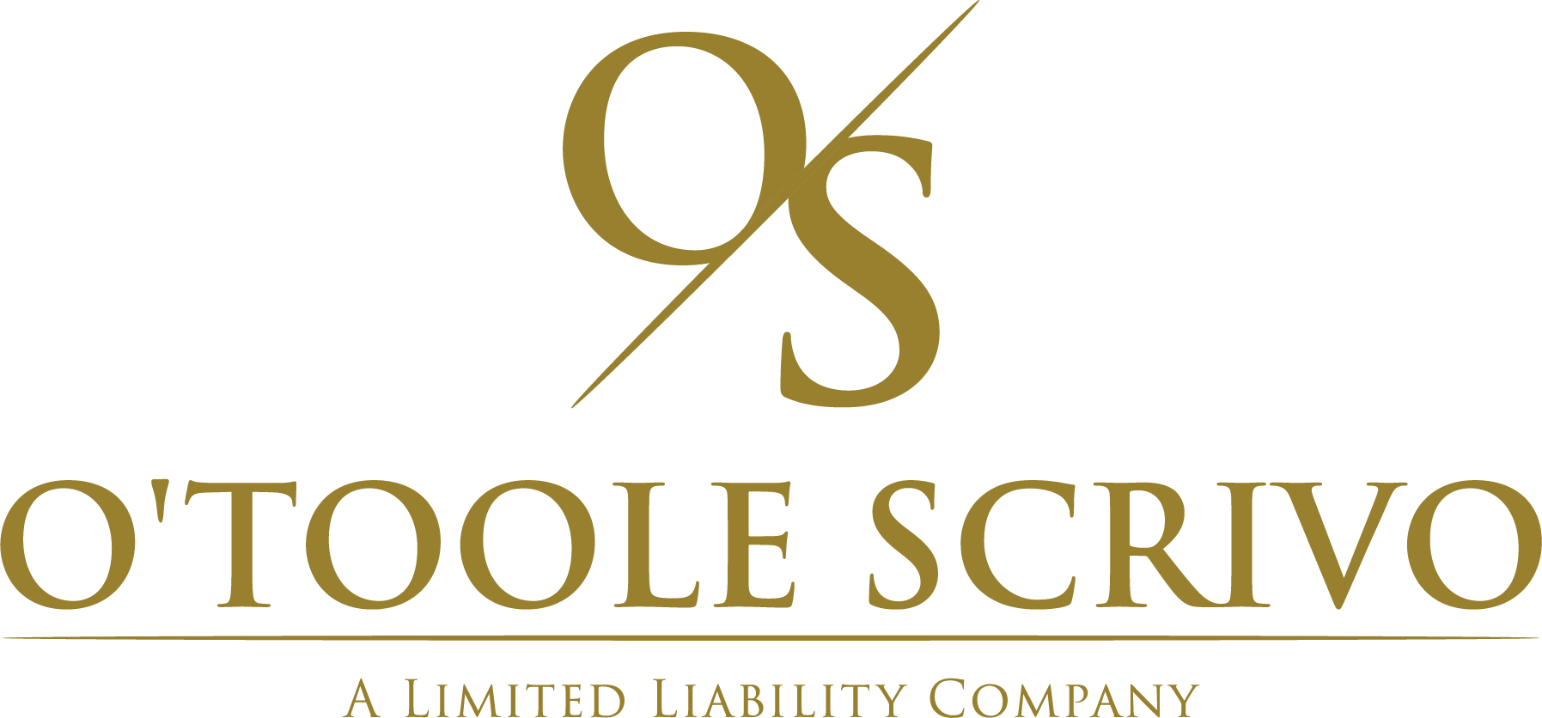


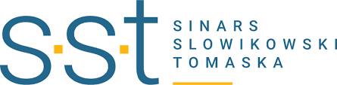

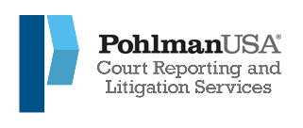



BLUE SPONSORS

PERRIN PARTNERS


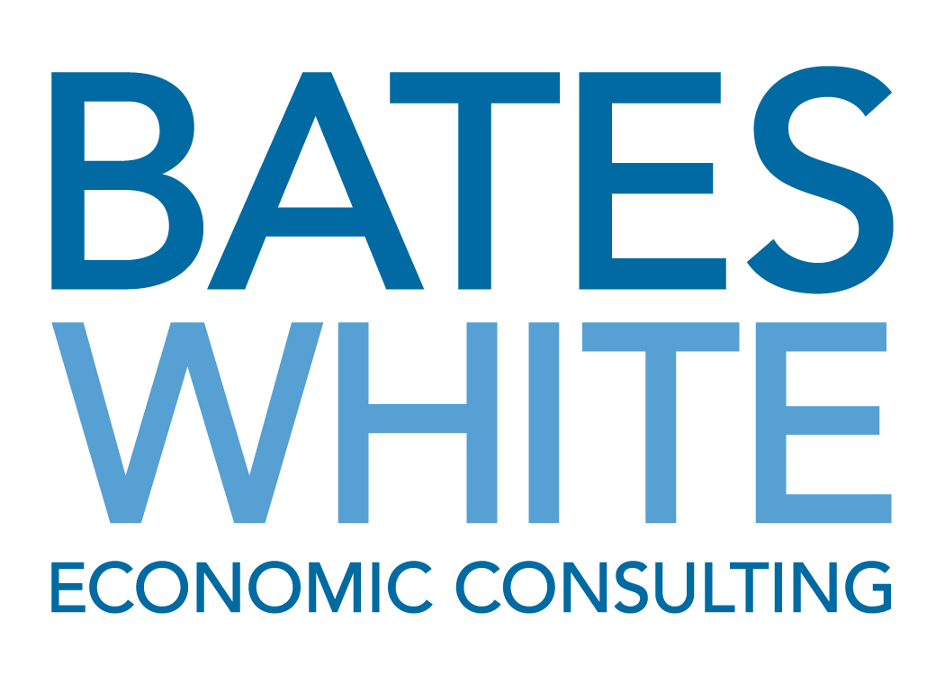
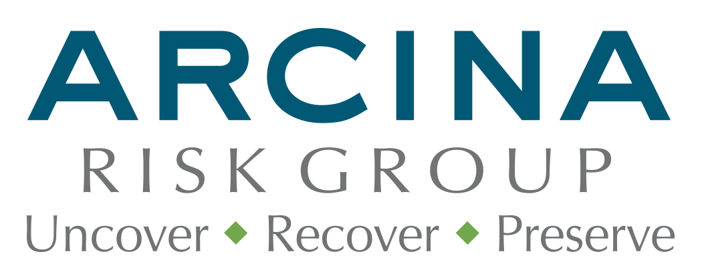

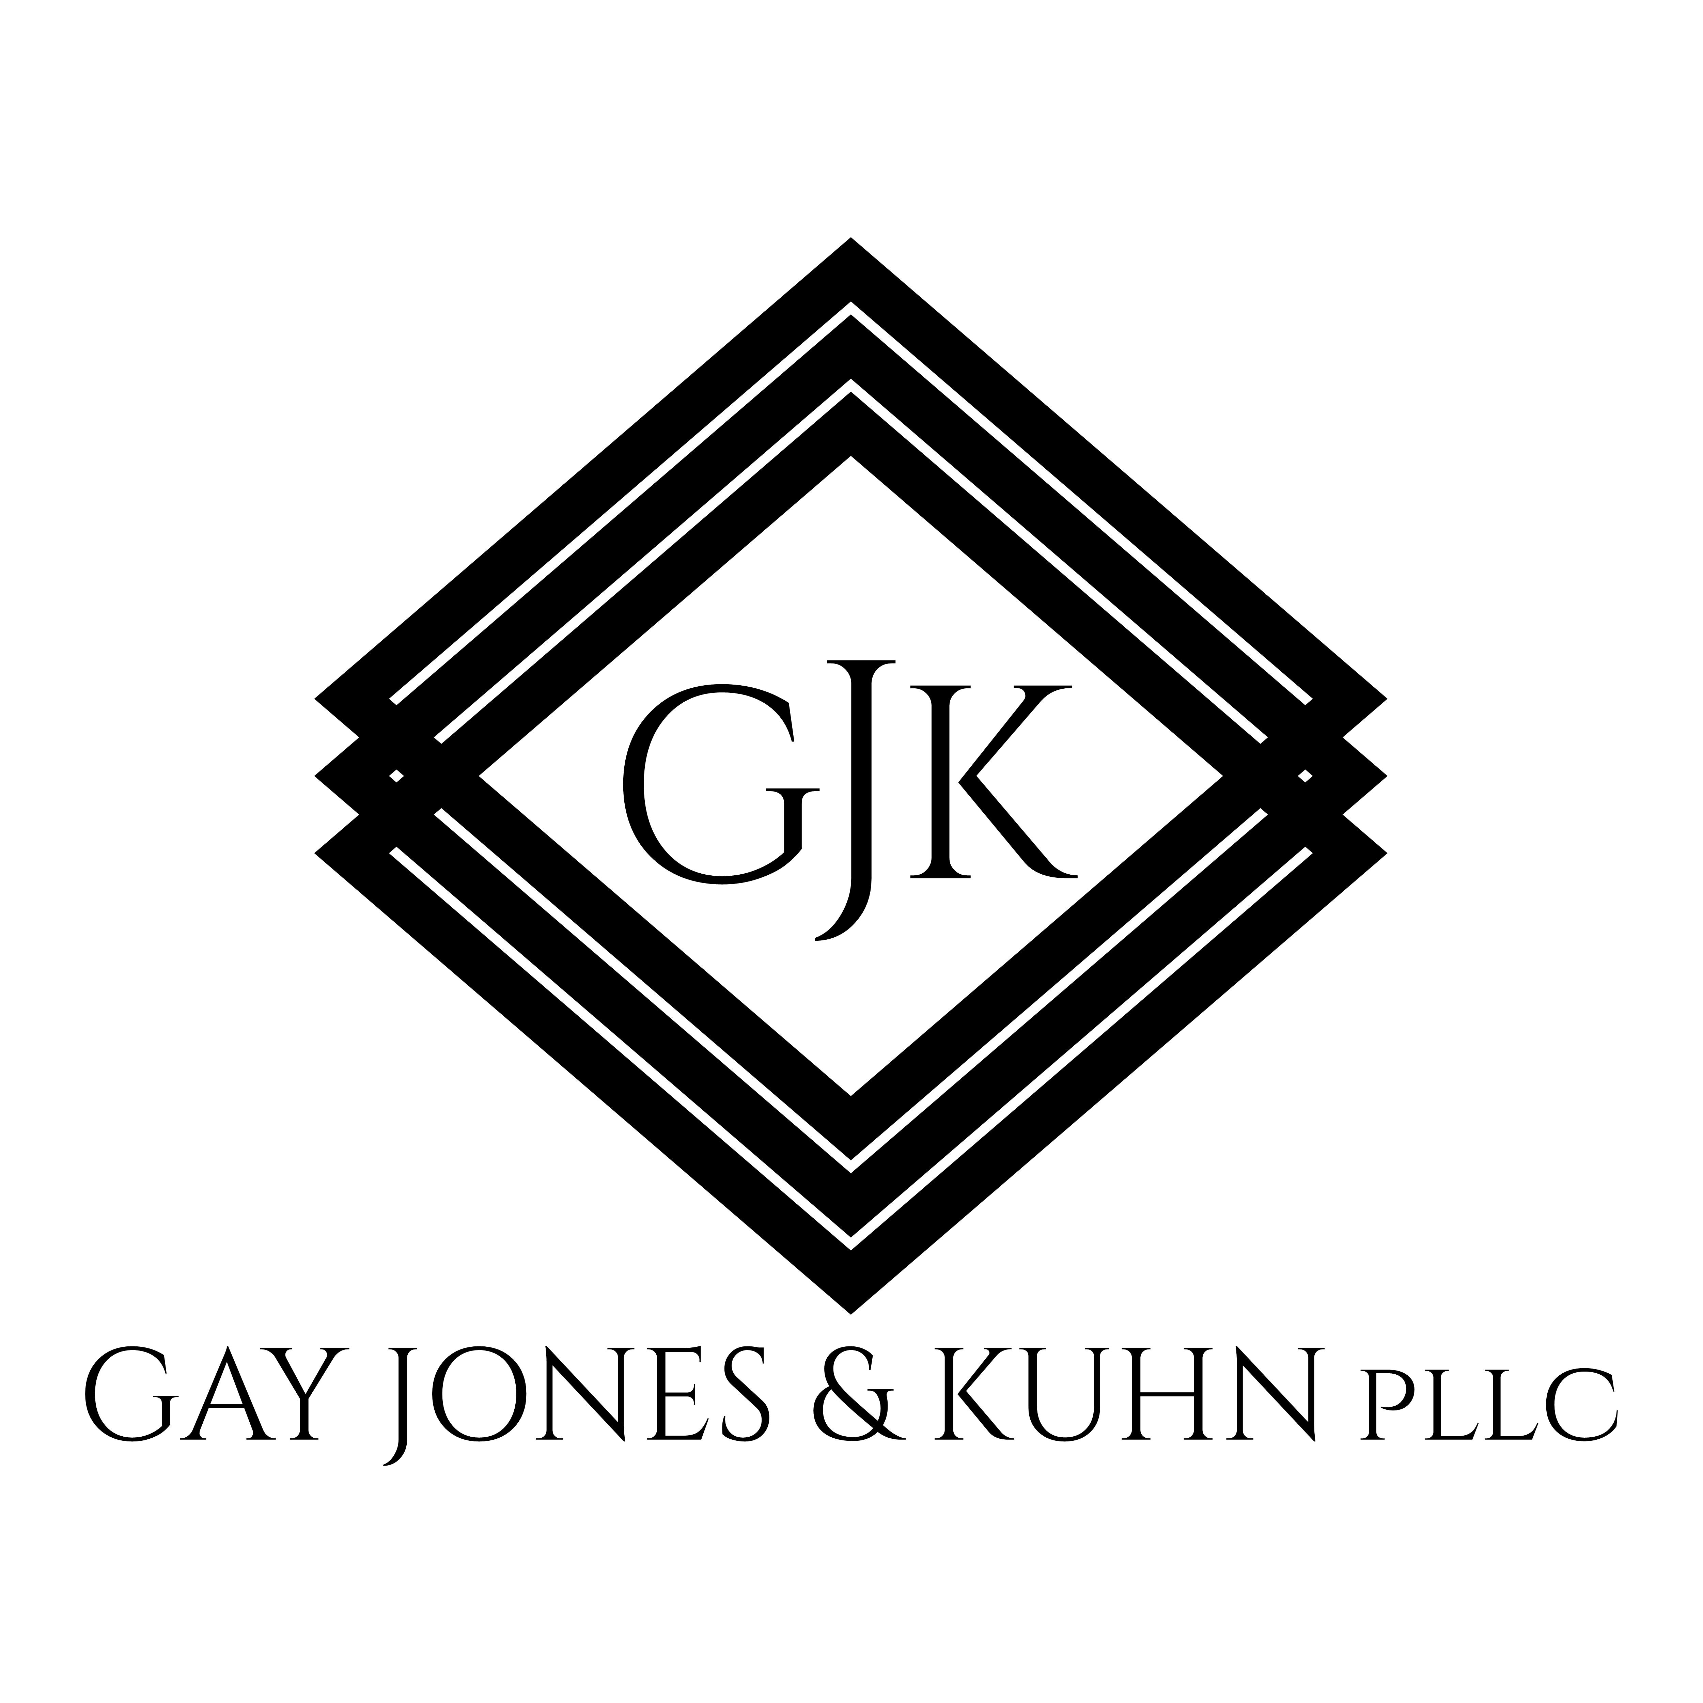
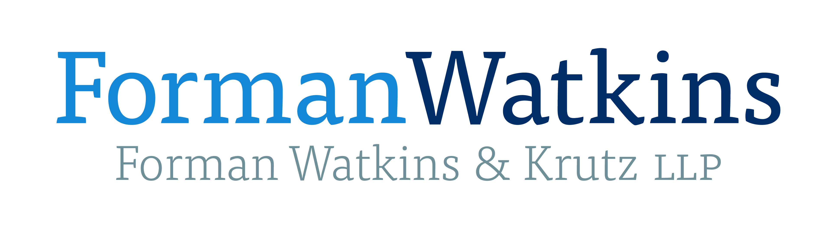

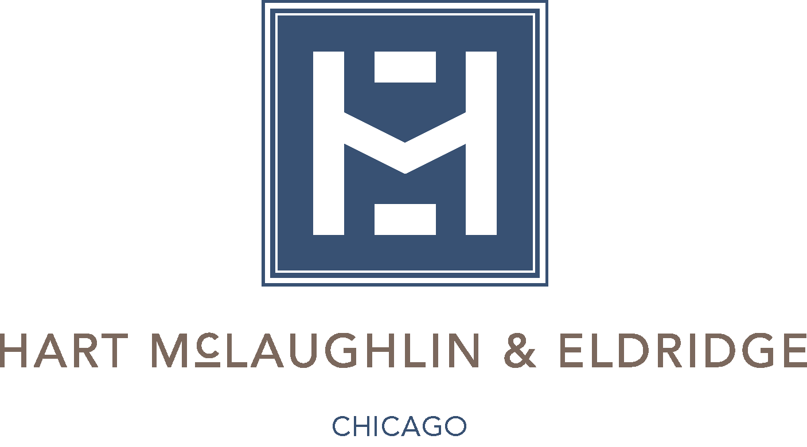

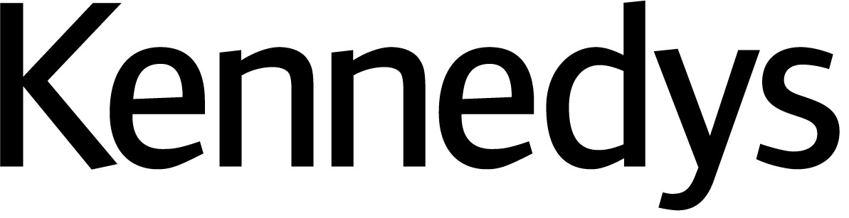

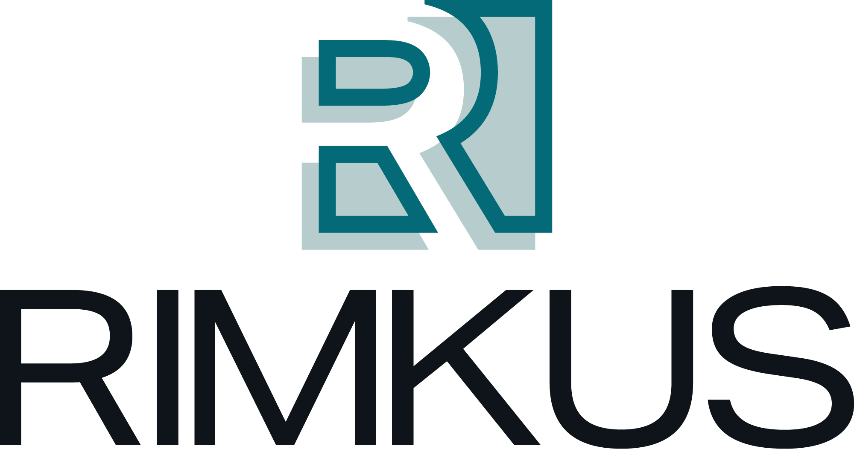



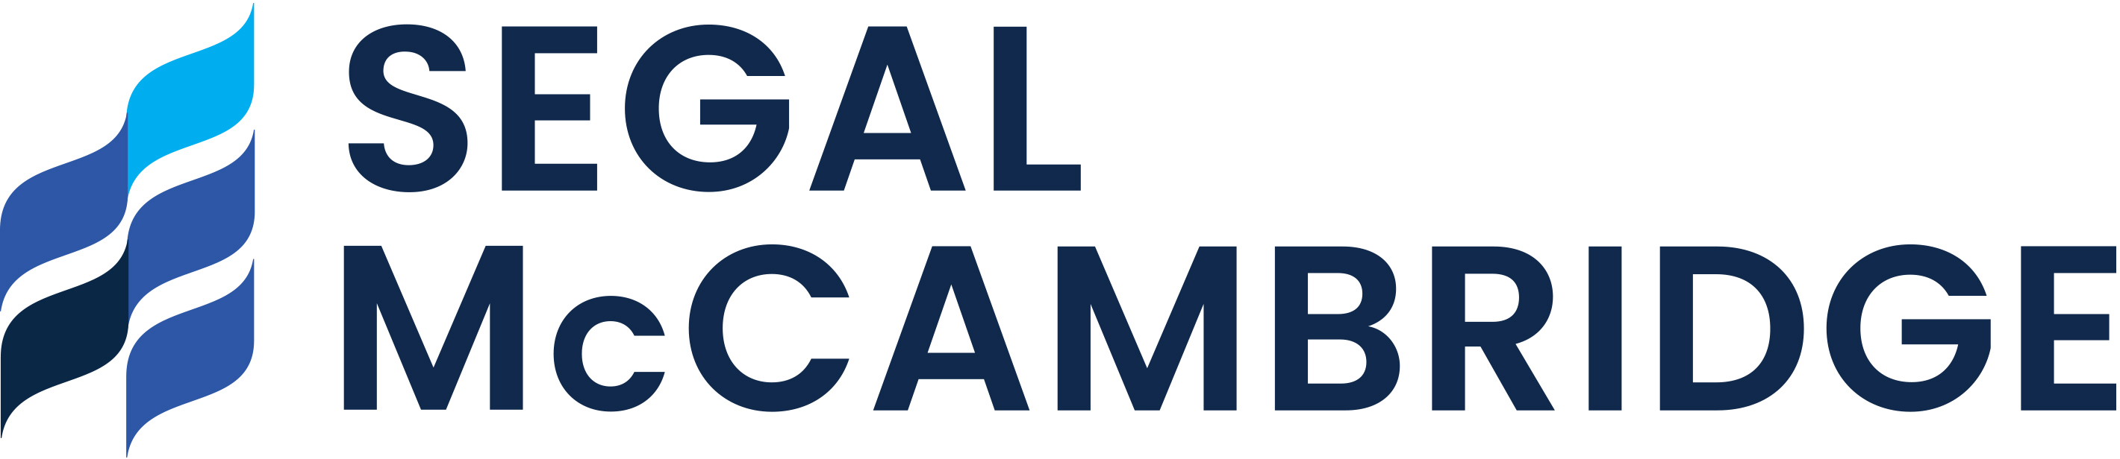

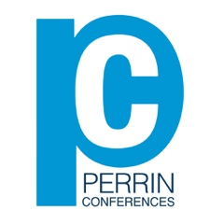
Perrin Conferences
Cutting-Edge Issues in Asbestos Litigation Conference
March 12-13, 2024 – Miami Beach, FL

Mail-in Registration Form

Attendee Name ____________________________________________________________________
Company/Firm Name _______________________________________________________________
Address ___________________________________________________________________________
____________________________________________________________________________
City ________________________________________________________________________________
State ____________________________ Zip Code ________________________________________
Email Address _______________________________________________________________________

CIRCLE ONE: Attorney Non-Attorney Insurance Professional In-House Counsel
Registration Fee: $1225
*All Insurance Professionals & In-House Counsel receive Complimentary attendance
Name on Card ______________________________________________________________________
Credit Card Number __________________________________________________________________
Expiration Date _____________________ Code _________________ Zip ______________
Please Mail Form to: Perrin Conferences, 214 Orchard Way, Wayne, PA 19087
Email Form to: bcorio@perrinconferences.com or lperrin@perrinconferences.com
Make Checks Payable to: Perrin Conferences, LLC

