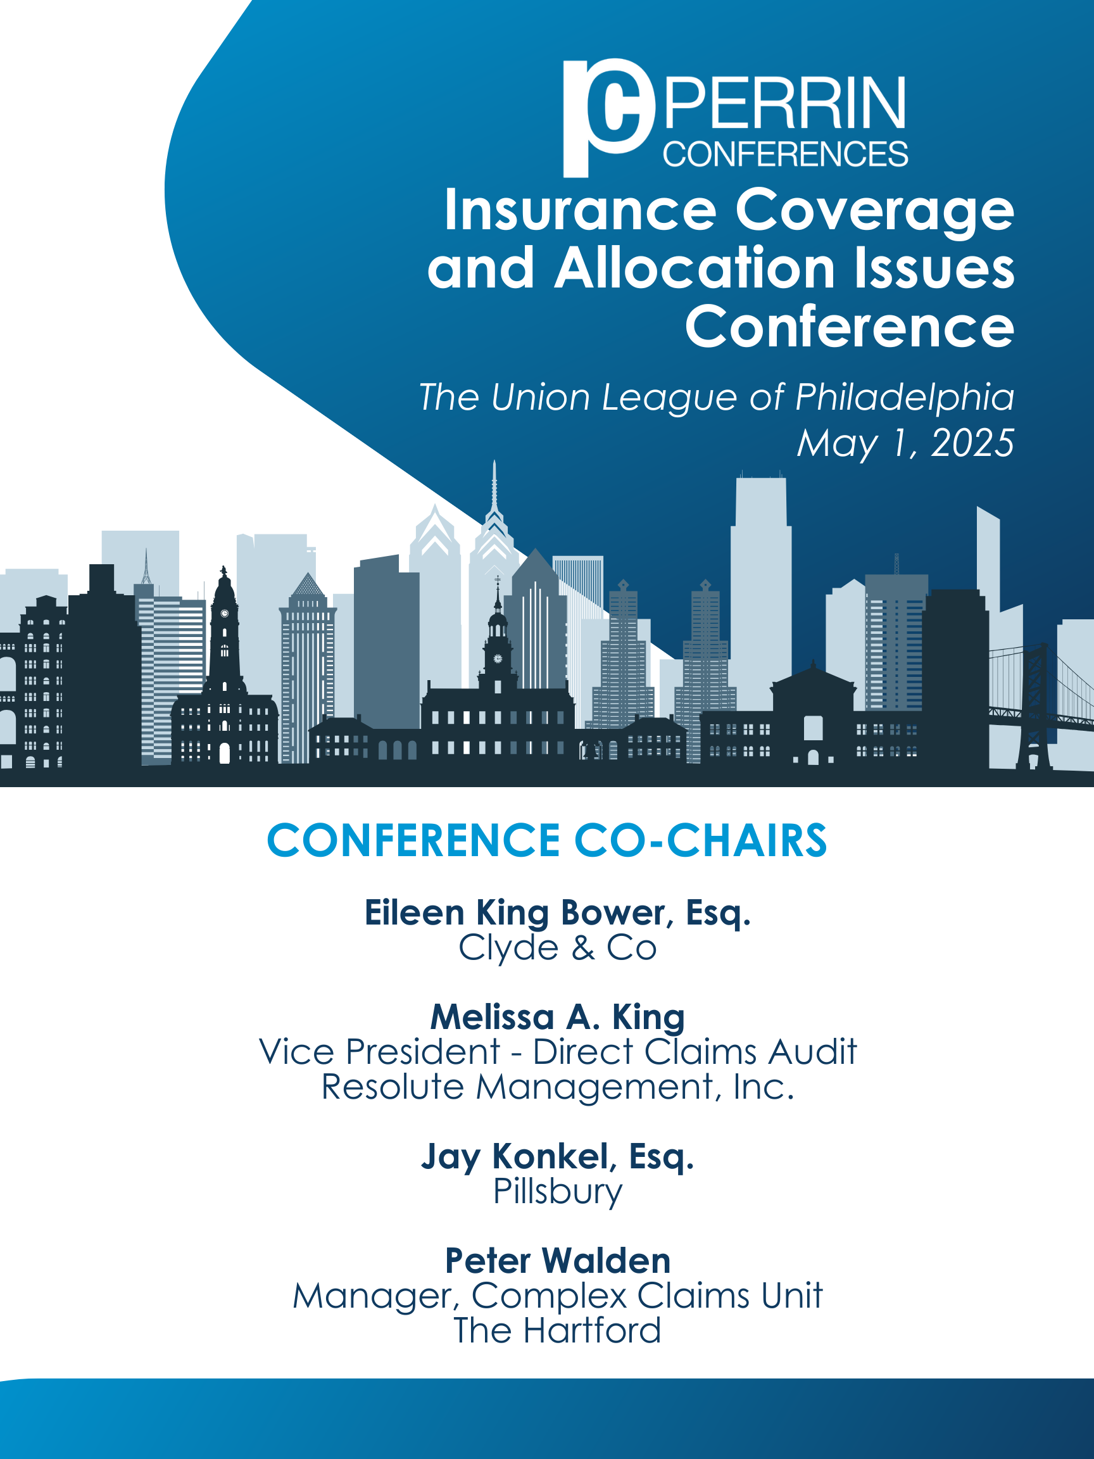

Perrin Conferences
Insurance Coverage & Allocation Issues Conference
Thursday, May 1, 2025
Union League of Philadelphia

8:15 AM – 9:00 AM – Registration (Lincoln Hall)

9:00 AM – 9:15 AM – Welcome & Opening Remarks by Co-Chairs

Eileen King Bower, Esq., Clyde & Co, Chicago, IL
Melissa King, Vice President – Direct Claims Audit, Resolute Management, Inc., Boston, MA
Jay Konkel, Esq., Pillsbury, Washington, D.C.
Peter Walden, Manager, Complex Claims Unit, The Hartford, Timonium, MD

9:15 AM – 10:15 AM – Evolving Strategies in Long-Tail Claims Allocation

- Methods and interpretation by courts
- Jurisdictional issues and recent case law
- The impact of policy assumption strategies

Ellen D. Fine, AVP & Senior Counsel, Coverage and Litigation, CoAction Specialty Insurance Group, New York, NY
Jason M. Knott, Esq., Zuckerman Spaeder LLP, Washington, DC
Bridget G. Longoria, Esq., Senior Vice President – Complex Liability Consulting, Marsh, Philadelphia, PA

10:15 AM – 11:15 AM – Bankruptcy Update

- Bankruptcy Primer
- Whether Financial Distress Is Required
- Insurance Carrier Standing
- Third-party releases in non-asbestos claims

Moderator: Melissa King, Vice President – Direct Claims Audit, Resolute Management, Inc., Boston, MA
Lauren R. Lifland, Esq., WilmerHale, New York, NY
Ben Nissim, Managing Assistant General Counsel, The Hartford, Stamford, CT
Alan Turner, Esq., Simpson Thacher & Bartlett LLP, New York, NY

11:15 AM – 11:30 AM – Break

11:30 AM – 12:30 PM – The Future of PFAS Litigation and its Impact on the Insurance Industry

- Overview of types of claims, MDL bellwether cases and existing settlements
- State and federal regulatory environment; potential impact of Trump administration
- Insurance considerations - allegations and defense of current PFAS claims
- Choice of law and allocation issues
- Trigger of coverage and exclusions
- Will PFAS become the next asbestos?

Moderator: Greg Gaines, JD, Technical Director, Roux, Burlington, MA
Dieter J. Juedes, Esq., Husch Blackwell, Milwaukee, WI
Michael Kuehn, Director, The RiverStone Group, Manchester, NH
Annette P. Rolain, Esq., Ruggeri Parks Weinberg LLP, Washington, D.C.

12:30 PM – 1:45 PM – Conference Lunch (Lincoln Hall at the Union League)

Keynote Speaker: Marci A. Hamilton, CEO, CHILD USA, Philadelphia, PA

1:45 PM – 2:15 PM – Commercial Leases, Contracts and Insurance Coverage Ramifications

- Insurance requirements, additional insured requirements, and contractual indemnification provisions

Stu Harris, Counsel, Commercial Lines Claims Legal, Nationwide, Columbus, OH
Marci Goldstein Kokalas, Esq., Goldberg Segalla, New York, NY

2:15 PM – 3:00 PM – Defense Cost Coverage Challenges

- Multi-defendant allocation issues (segregable versus non-segregable defense costs)
- Mass tort allocation issues (MDLs, class actions, etc.)
- Independent counsel issues (entitlement, rates, litigation management guidelines, etc.)

Marc E. Haas, Esq., Managing Counsel, Stradley Ronon, New York, NY
Kevin V. Small, Esq., Hunton Andrews Kurth LLP, New York, NY
Jared Zygmunt, Director – Disputes, Claims & Investigations, Stout, Chicago, IL

3:00 PM – 3:15 PM – Break
Sponsored by: Stout

3:15 PM – 4:15 PM – Relationship Between Insurer, Counsel, Consultant

- How to maximize this working relationship
- What is each party looking for? What is important to them?
- Collaborative Strategy Development: Developing a unified strategy through communication and collaboration

Moderator: Patricia Santelle, Esq., White and Williams LLP, Philadelphia, PA
Lisa Armon, Senior Litigation Counsel, Chubb Insurance Company, Philadelphia, PA
Kristen Drake, President, PolicyFind, Indianapolis, IN
Edward A. Smallwood, Esq., Post & Schell, P.C., Pittsburgh, PA
Barry Trilla Jr., Director – Quantitative Services, Alan Gray LLC, Chicago, IL

4:15 PM – 5:00 PM – Wildfire Risk and Environmental Insurance

- How are large wildfire claims playing out for residential vs commercial policyholders
- How are claims on various policies (GL, fire, and environmental) being handled?
- Are regions like California becoming uninsurable?
- What are the coverage issues?

Brian Margolies, Esq., Kaufman Borgeest & Ryan LLP, Valhalla, NY
Victoria Spina, Director, Environmental Insurance, The Vertex Companies, LLC, New York, NY

Additional Speaker to be Added.

5:00 PM – 6:00 PM – Networking Cocktail Reception (Grant Room – Union League)
Sponsored by: Pillsbury

Perrin Conferences
Insurance Coverage & Allocation Issues Conference
May 1, 2025
Union League of Philadelphia

*Speaker and Agenda are subject to change.

CONFERENCE LOCATION

Union League of Philadelphia,140 S Broad Street, Philadelphia, PA 19102

REGISTRATION

Registration Rate: $895
Paralegal Rate: $295

All in-house counsel and insurance claims professionals receive complimentary registration at Perrin Conferences live programs.

Contact Bethany Corio 610-220-1817 or Lynnsey Perrin 610-804-6165 with questions or to register at the complimentary rate.

Register Online: Insurance Coverage & Allocation Issues Conference

Register by Mail/E-mail: Complete the Mail-In Registration Form at the end of brochure.

Mail to: Perrin Conferences, 214 Orchard Way, Wayne, PA 19087
Each registration includes private website access to course materials and admission to all sessions and networking events such as refreshment breaks and cocktail receptions.

Group discounts available, please inquire.

UNION LEAGUE OF PHILADELPHIA DRESS CODE

Men: Jacket and tie are strongly preferred. Jacket and collared shirt are required at all times on the first floor members-only section of the League House.

Women: Business suits, tailored pant or skirt ensembles and dresses.

Not Permitted: Spandex, open midriffs, halter tops, shorts, leggings, extremely short hemlines (not more than 3" above the knee), jeans, t-shirts, athletic attire, sneakers, and flip-flops.
HOTEL ROOM BLOCK

The W Philadelphia Hotel: 1439 Chestnut Street, Philadelphia, PA 19102

We have a room block for conference speakers and attendees at the W Philadelphia. The group rate is $249.00 USD per night.

Book your group rate for Perrin Conferences Room Block

Contact Bethany Corio if you have questions about the room block.

CLE & CE CREDIT INFORMATION

Applications are being made to all CLE states as requested by attendees. Perrin cannot guarantee accreditation in every state. Approval is determined by each jurisdiction’s governing body. This conference is approved for CE Adjuster credit in FL and TX.

Please note, there will be no partial credit awarded for CE credit – The full conference must be attended to earn CE credit. Please send CLE requests for state specific accreditation to Kelsey Minerd.

CANCELLATION POLICY

If you cannot attend the conference, please notify us prior to April 17, 2025 and we will refund your fee or provide a credit for a future conference. The credit needs to be used within one year from the conference date.

Cancellations received on April 18, 2025 and after will not be refunded. You may enroll a substitute at any time before the conference starts. Cancellations received on April 18, 2025 and after may receive a credit for $200 less than the registration amount paid and can be used by their firm/company within one year from the conference date.

FINANCIAL AID POLICY

Perrin Conferences is dedicated to providing high-quality continuing legal education to attorneys interested in course offerings. Program registrants who are unable to afford registration fees due to financial hardship may apply for a complete registration waiver or reduction in fee. Factors to be considered include employment status and annual income. Please send a written letter to Lynnsey Perrin addressing your financial situation for consideration. All requests must be submitted 14 days prior to the start of the program and are kept confidential.
THANK YOU TO OUR SPONSORS AND PARTNERS

PLATINUM SPONSOR



GOLD SPONSORS

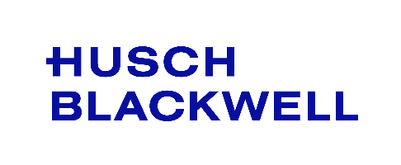
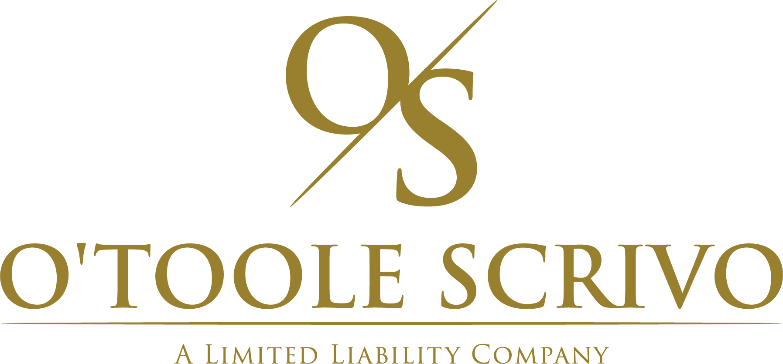




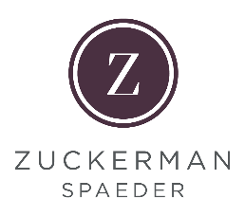
BLUE SPONSORS

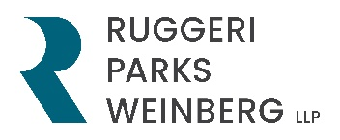
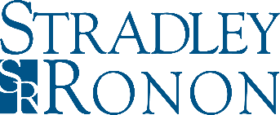


PERRIN PARTNERS
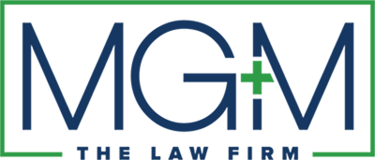
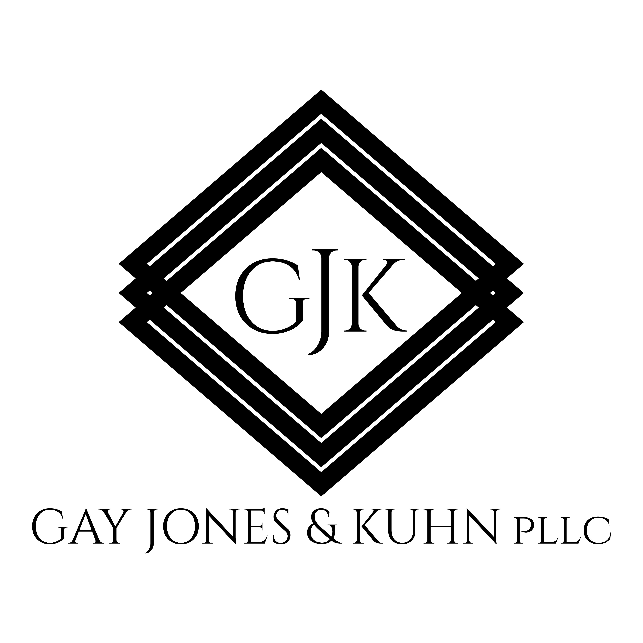
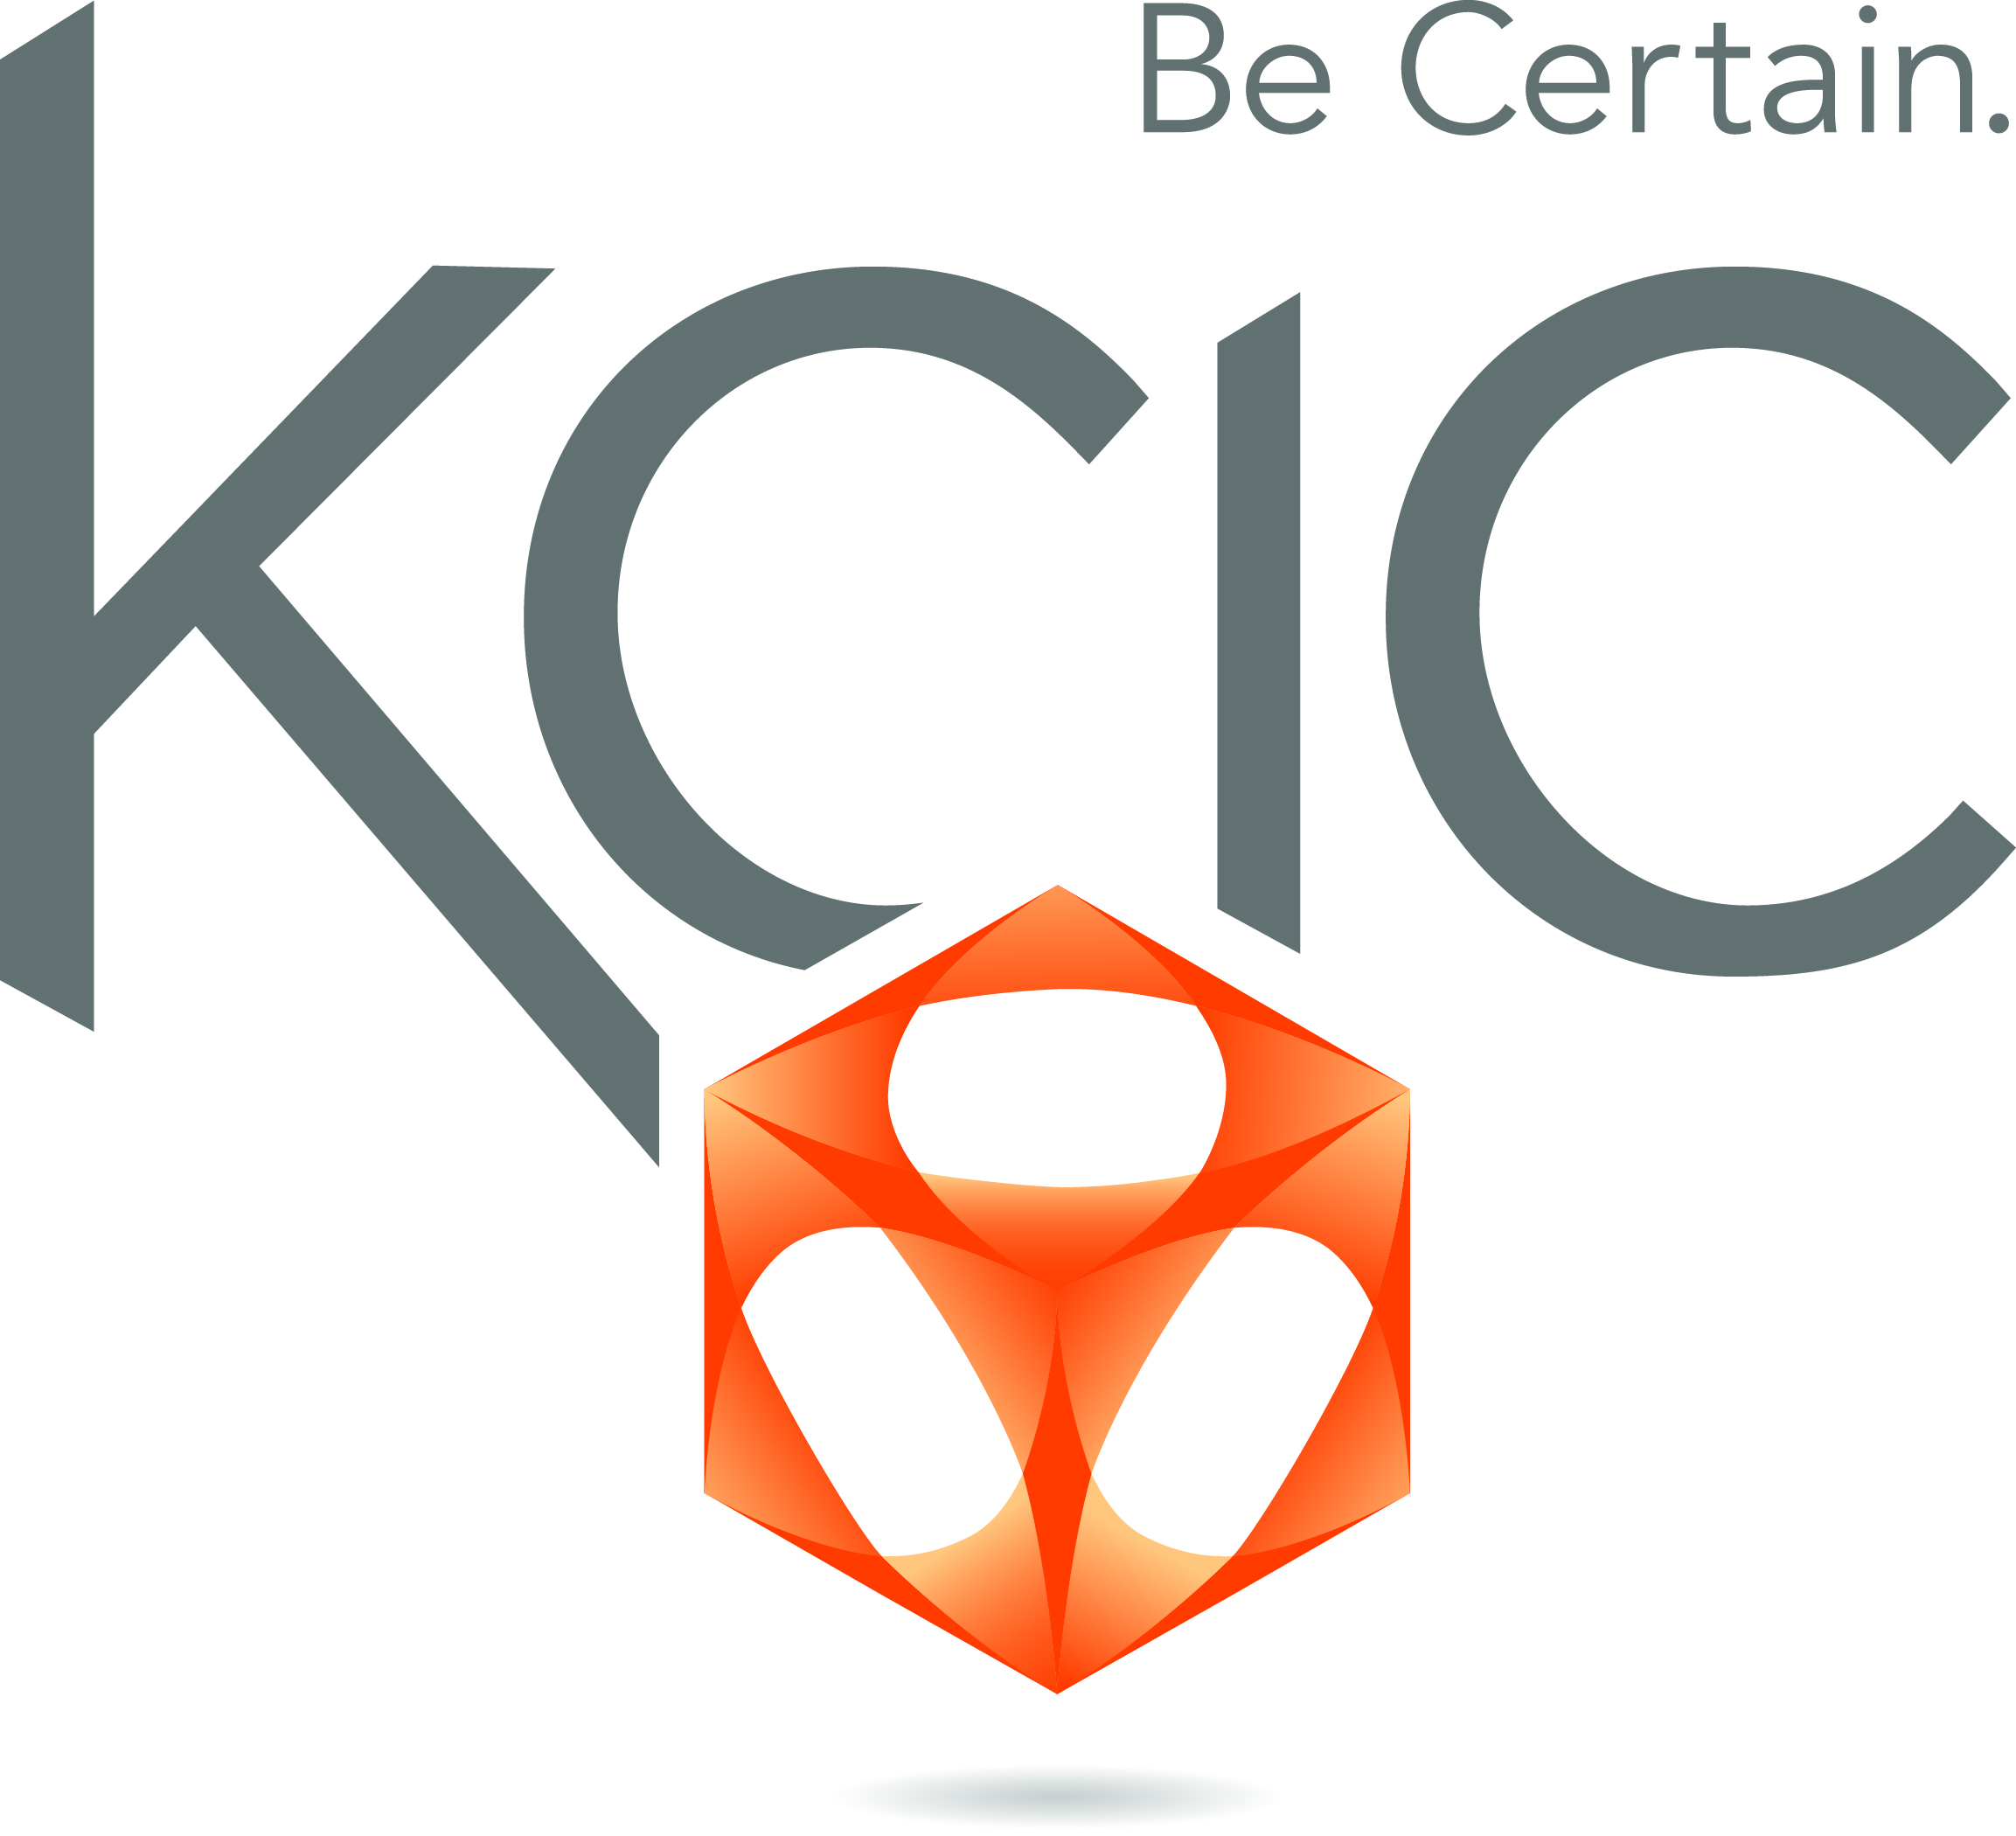
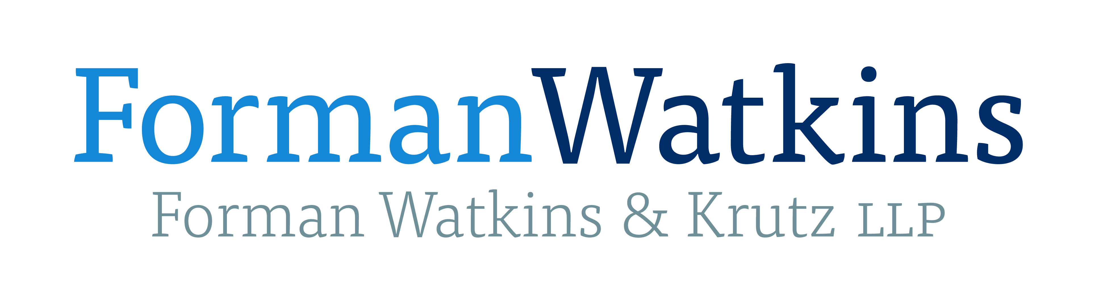
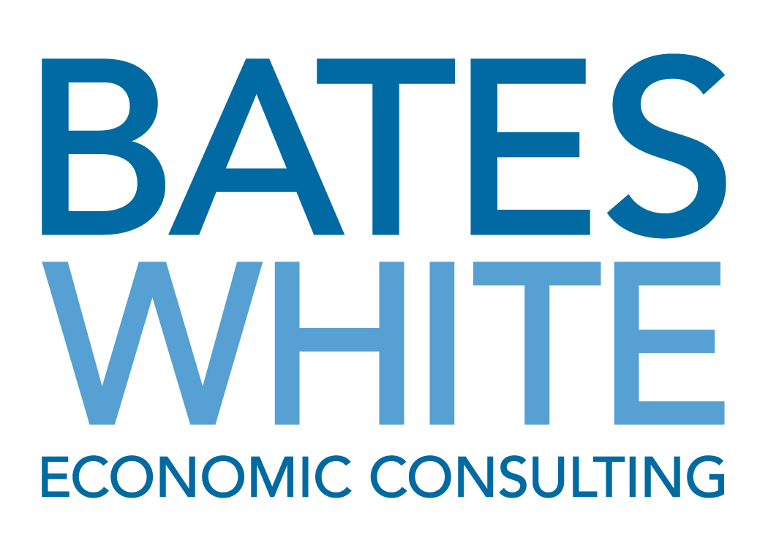
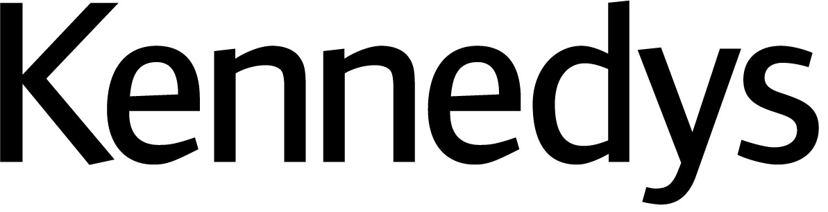



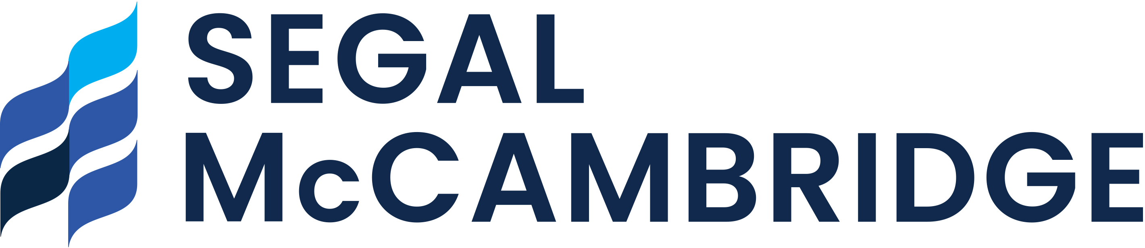
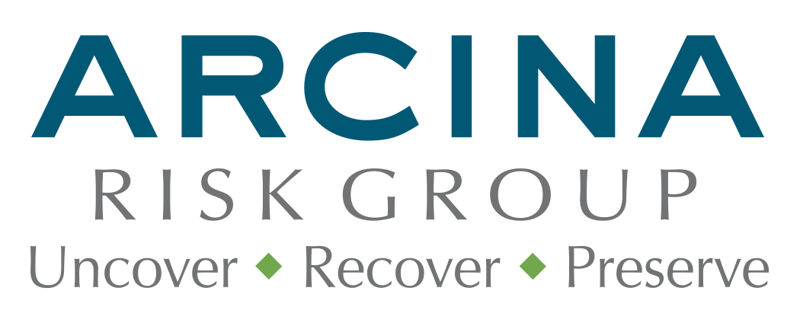
















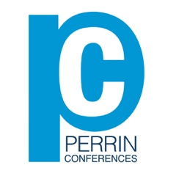
Perrin Conferences
Insurance Coverage and Allocation Issues Conference
Thursday, May 1, 2025 (Philadelphia, PA)
Mail-in Registration Form

Attendee Name ____________________________________________________________________
Company/Firm Name _______________________________________________________________
Address ___________________________________________________________________________
____________________________________________________________________________
City ________________________________________________________________________________
State ____________________________ Zip Code ________________________________________
Email Address _______________________________________________________________________

CIRCLE ONE: Attorney Non-Attorney Insurance Professional In-House Counsel

Registration Fee: $895 Paralegal Rate: $295

*All Insurance Professionals & In-House Counsel receive Complimentary attendance

Name on Card _______________________________________________________________________
Credit Card Number __________________________________________________________________
Expiration Date _____________________ Code _________________ Zip ______________
Please Mail Form to: Perrin Conferences, 214 Orchard Way, Wayne, PA 19087
Email Form to: bcorio@perrinconferences.com or lperrin@perrinconferences.com
Make Checks Payable to: Perrin Conferences, LLC

