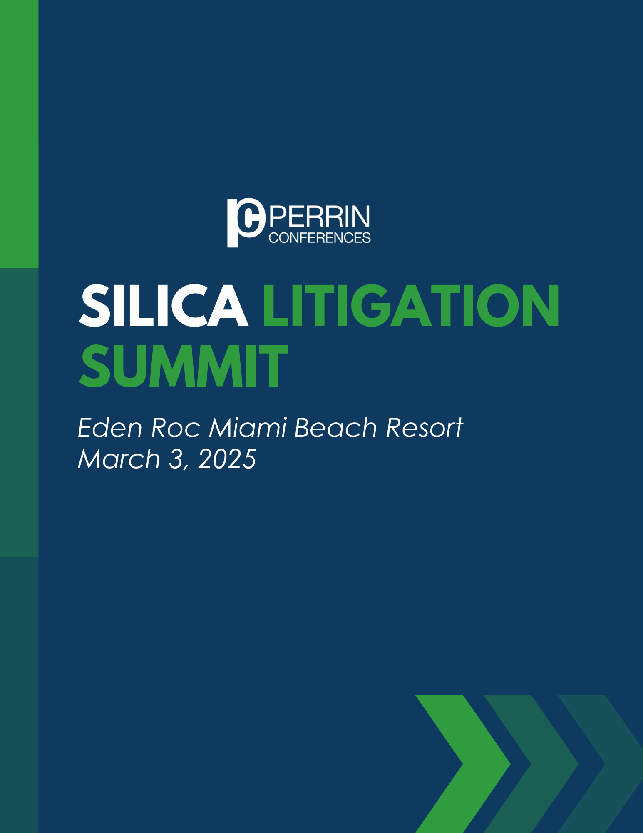

Perrin Conferences - Silica Litigation Summit
March 3, 2025
Eden Roc Miami Beach Resort, Miami, FL

12:30pm – 1:00pm – Registration

1:00pm – 2:00pm – Status of the Artificial Stone Litigation

- What to expect in 2025 and beyond
- Plaintiff experts, defense experts and developing new experts
- What type of defendants are involved in these cases?
Madeleine Bass, Claim Consultant-Indemnity Specialty, Nationwide, Boston, MA
Brian B. Hannula, Forman Watkins & Krutz LLP, Jackson, MS
Joel Lorenzo, Technical Director, Nationwide, New York, NY
Colleen S. Welch, Esq., Maron Marvel, Jackson, MS

2:00pm – 3:00pm – OSHA Compliance

- California OSHA report from December 2023
Brian Daly, President, Hygiene Technologies International, Inc., Los Angeles, CA
Rey S. Yang, Esq., Yang | Professional Law Corporation, Los Angeles, CA

3:00pm – 4:00pm – Perspectives from the Trial Attorneys

- Lessons learned from Reyes Gonzalez
- Trial strategies
- Jury selection strategy
- Theories of Liability
Johanna Boktor, Esq., Yang | Professional Law Corporation, Los Angeles, CA
Lindsay Weiss, Esq., MG+M The Law Firm, Los Angeles, CA

5:30 PM – 6:30 PM – Networking Cocktail Reception (Eden Roc Garden)

Join us for this outdoor reception, which will combine the Silica Litigation Summit attendees as well as the Cutting-Edge Issues in Asbestos Litigation Conference attendees.

Perrin Conferences - Silica Litigation Summit
March 3, 2025, 1:00- 4:00PM ET
Eden Roc Miami Beach Resort, Miami, FL

*Speaker and Agenda are subject to change.

CONFERENCE LOCATION

Eden Roc Miami Beach Hotel
4525 Collins Ave
Miami Beach, FL 33140

REGISTRATION

Registration Rate: $295

All in-house counsel and insurance claims professionals receive complimentary registration at Perrin Conferences live programs.
.
Contact Bethany Corio (bcorio@perrinconferences.com) 610-220-1817 or Lynnsey Perrin (lperrin@perrinconferences.com) 610-804-6165 with questions or to register at the complimentary rate.

Register Online: Silica Litigation Summit | Perrin Conferences

Register by Mail/E-mail: Complete the Mail-In Registration Form at the end of brochure.

Mail to: Perrin Conferences, 214 Orchard Way, Wayne, PA 19087
Each registration includes private website access to course materials and admission to all sessions and networking events such as refreshment breaks and cocktail receptions.

Group discounts available, please inquire.

HOTEL ROOM BLOCK

Eden Roc Miami Beach Hotel
4525 Collins Ave, Miami Beach, FL 33140

Please make your room reservations through the group booking link. The group rate is $399/night. We suggest making your reservations as soon as possible, the discounted room block rates are ending soon.
Reservation Link Perrin Conferences Room Block

Cadillac Hotel & Beach Club, Autograph Collection
3925 Collins Ave, Miami Beach, FL 33140

We have a second room block at the Cadillac Hotel & Beach Club. Please make your room reservations through the group booking link below. The group rate is $379/night. We suggest making your reservations as soon as possible before the room block sells out.
Book your group rate for Perrin Silica Litigation Summit

CLE CREDIT INFORMATION

Applications are being made to all CLE states as requested by attendees. Perrin cannot guarantee accreditation in every state. Approval is determined by each jurisdiction’s governing body.
Please send CLE requests for state specific accreditation to Kelsey Minerd (kaminerd@perrinconferences.com).

CANCELLATION POLICY

If you cannot attend the conference, please notify us prior to February 16, 2025 and we will refund your fee or provide a credit for a future conference. The credit needs to be used within one year from the conference date.
Cancellations received on February 17, 2025 and after will not be refunded. You may enroll a substitute at any time before the conference starts. Cancellations received on February 16, 2025 and after may receive a credit for $200 less than the registration amount paid and can be used by their firm/company within one year from the conference date.

FINANCIAL AID POLICY

Perrin Conferences is dedicated to providing high-quality continuing legal education to attorneys interested in course offerings. Program registrants who are unable to afford registration fees due to financial hardship may apply for a complete registration waiver or reduction in fee. Factors to be considered include employment status and annual income. Please send a written letter to Lynnsey Perrin addressing your financial situation for consideration. All requests must be submitted 14 days prior to the start of the program and are kept confidential.

THANK YOU TO OUR PARTNERS

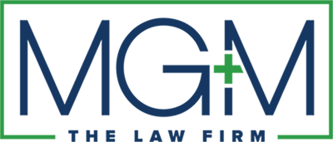

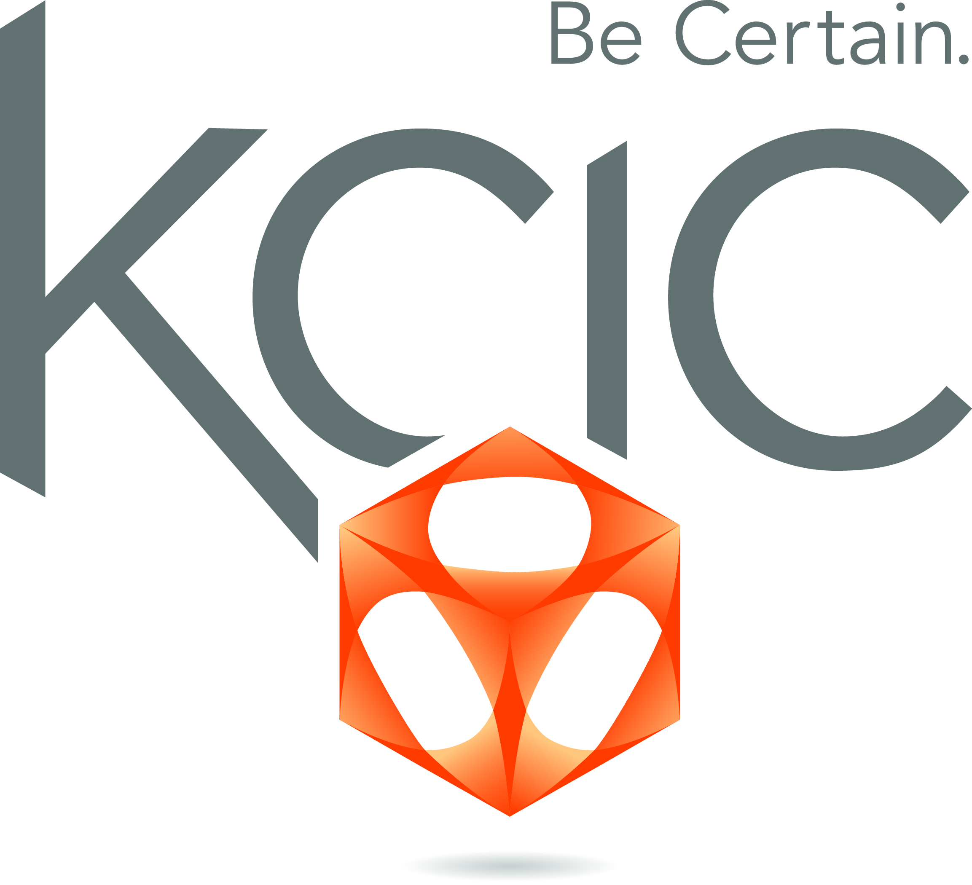
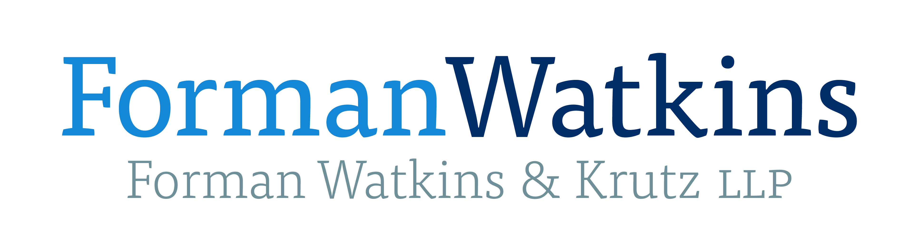
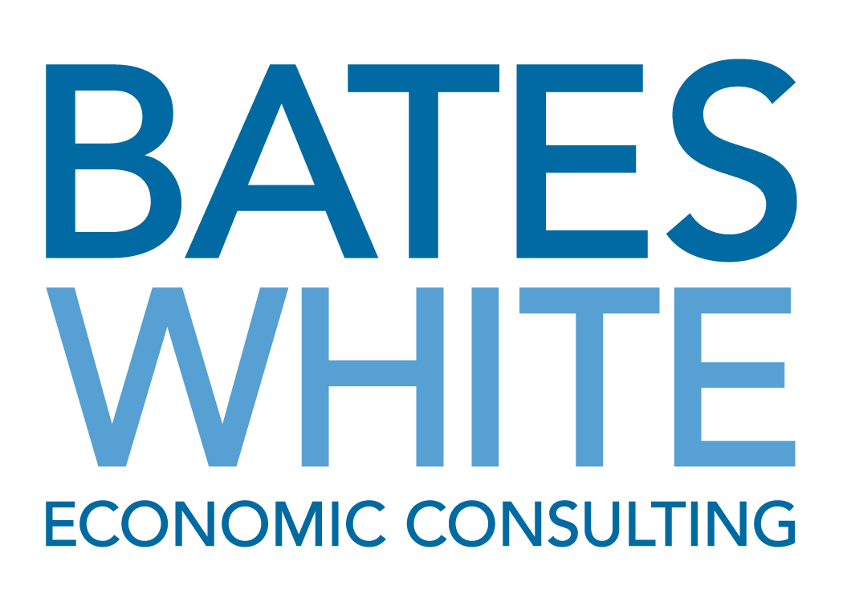


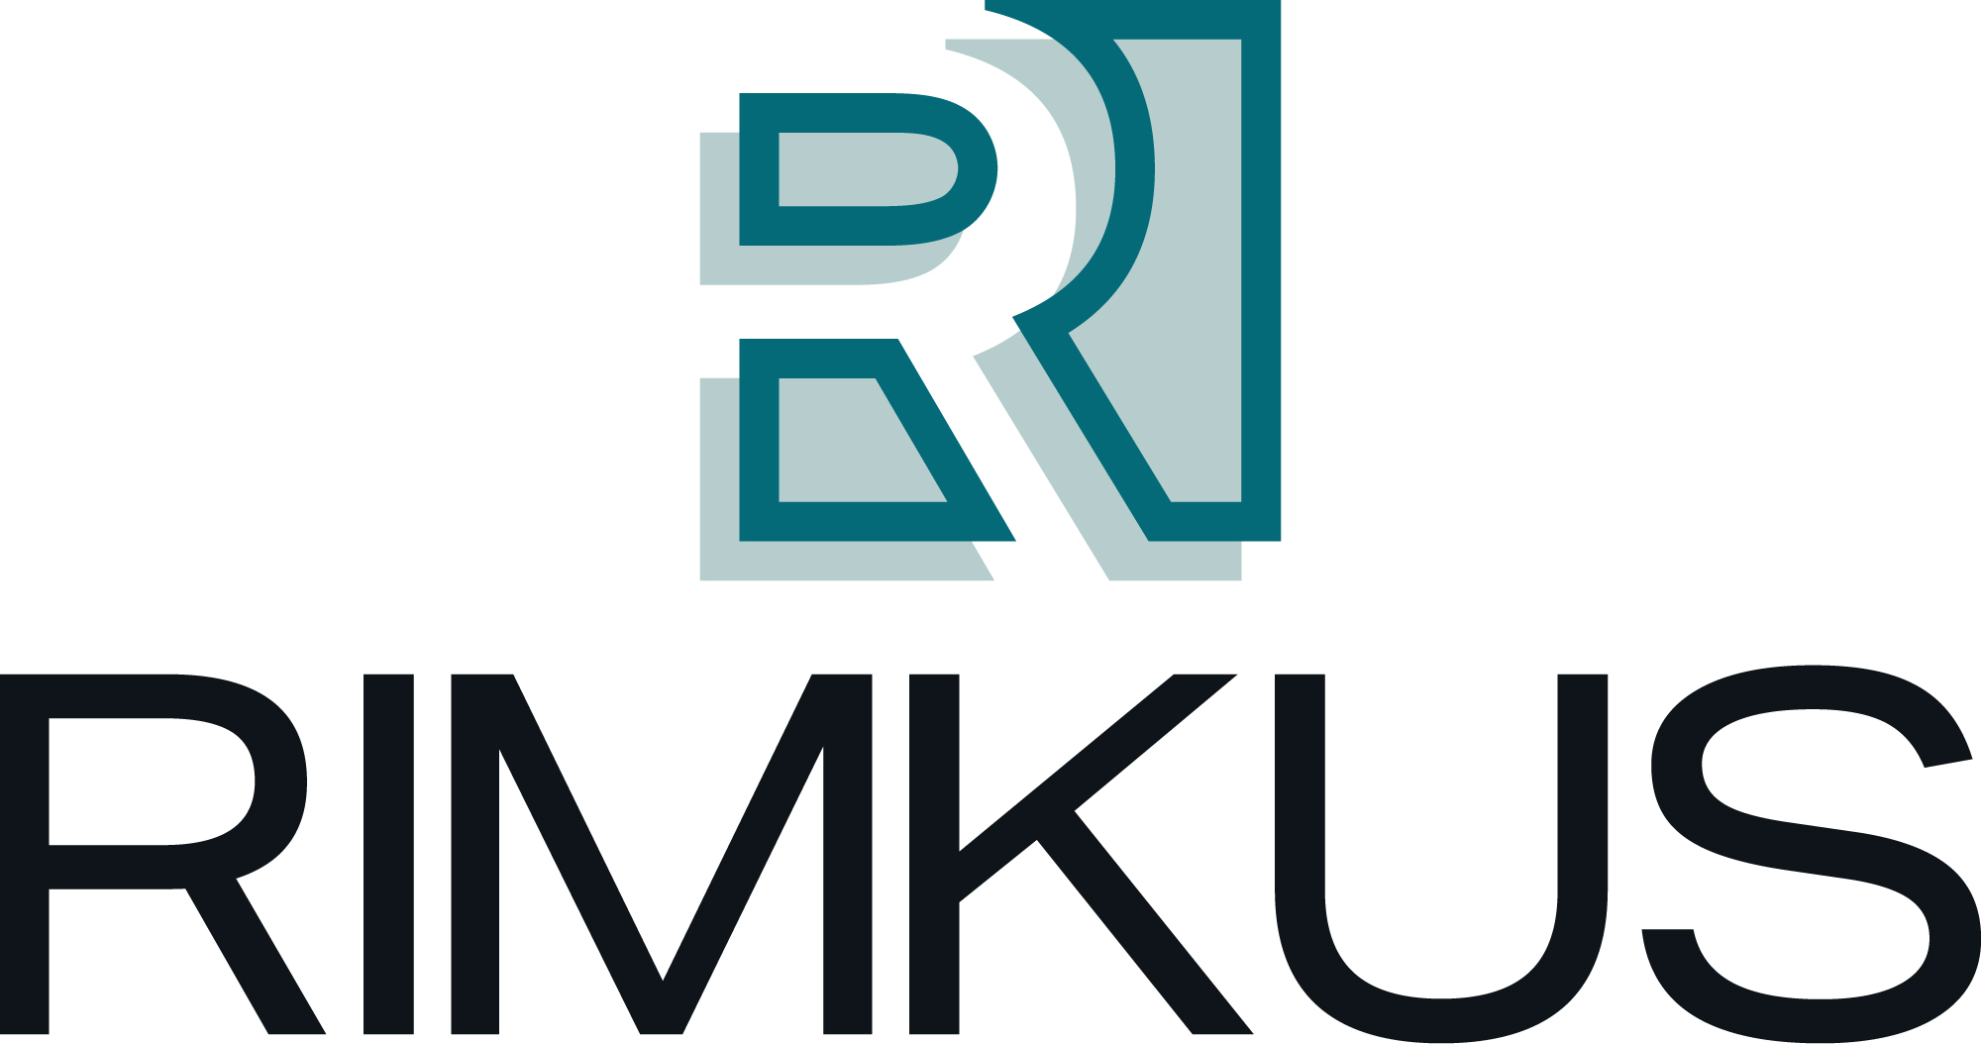

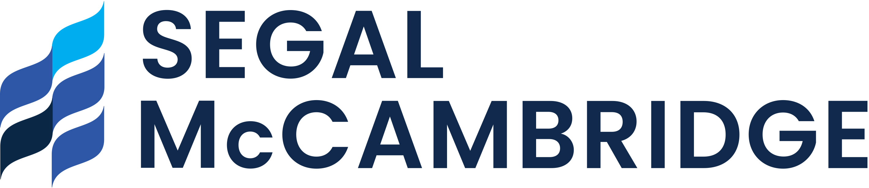
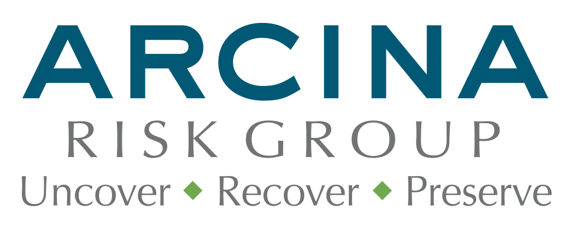
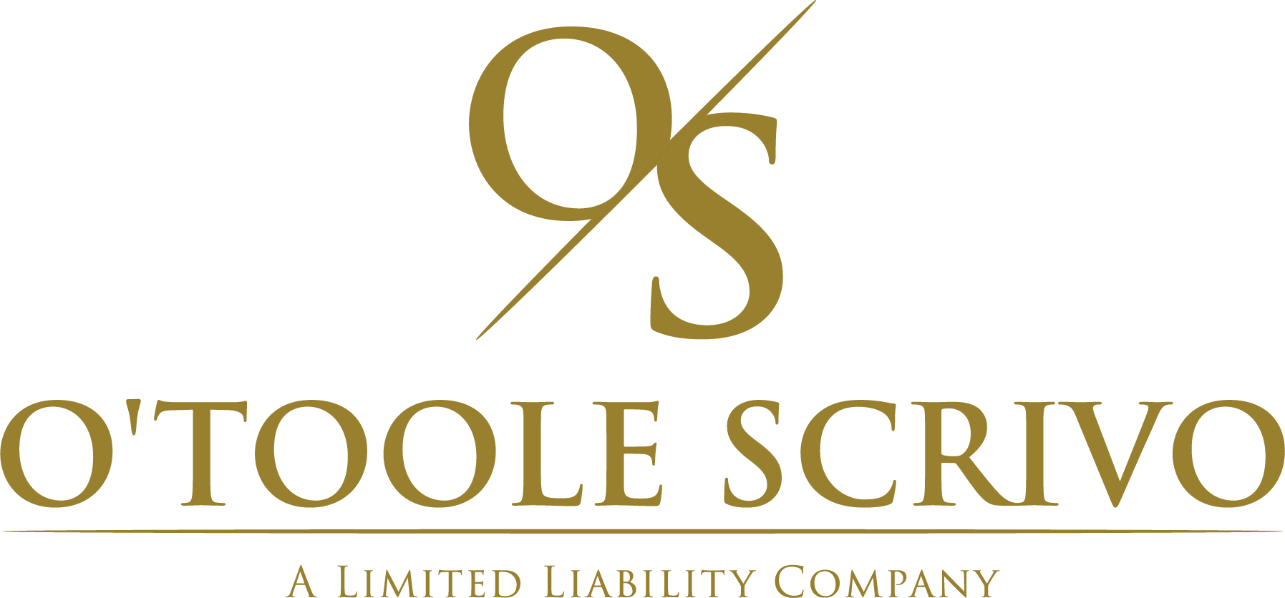












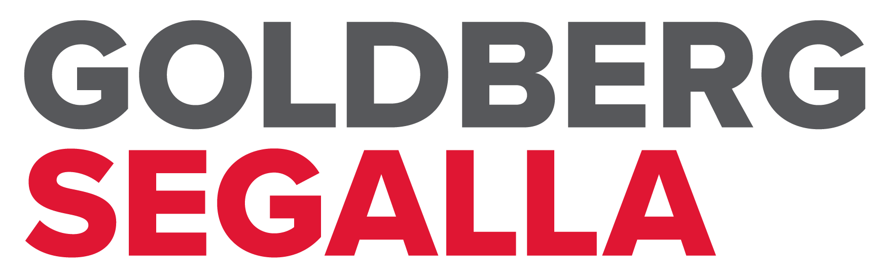


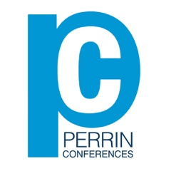
Perrin Conferences
Silica Litigation Summit
March 3, 2025, Miami Beach
Mail-in Registration Form

Attendee Name ____________________________________________________________________
Company/Firm Name _______________________________________________________________
Address ___________________________________________________________________________
____________________________________________________________________________
City ________________________________________________________________________________
State ____________________________ Zip Code ________________________________________
Email Address _______________________________________________________________________

CIRCLE ONE: Attorney Non-Attorney Insurance Professional In-House Counsel
Registration Fee: $295
*All Insurance Professionals & In-House Counsel receive Complimentary attendance
Name on Card ______________________________________________________________________
Credit Card Number __________________________________________________________________
Expiration Date _____________________ Code _________________ Zip ______________
Please Mail Form to: Perrin Conferences, 214 Orchard Way, Wayne, PA 19087
Email Form to: bcorio@perrinconferences.com or lperrin@perrinconferences.com
Make Checks Payable to: Perrin Conferences, LLC

